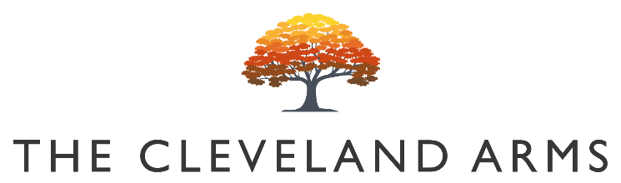

Bloody Mary £5.50

Large Bloody Mary £8

Small Plates

Wild Mushroom and Truffle Soup
Focaccia bread (V) £6
Vegan option available

Terrine of Smoked Chicken, Ham Hock & Leek
Focaccia Toast & Chutney £8

Baby Beetroot & Vegan Feta Salad
Pickled Walnut & Wild Rocket (VG) £6

Oak Smoked Salmon
Cauliflower, Apple & Beetroot £7

Local Chorizo, Bean & Feta Stew
Focaccia Bread & Local Feta £8

Sharing Baked ‘Boy Laity’ British Camembert
Focaccia & Balsamic Onions (V) £12

Sunday Mains

All our roasts are served with seasonal vegetables, roast potatoes, gravy and Yorkshire pudding

Rare Breed South Downs Beef Rump £14.50

Slow Roast Rolled Lamb Shoulder £14

Roast Rolled South Downs Pork Belly £13

Free Range Roast Chicken £13

Beetroot, Spinach & Leek Wellington (VG) £12

Pigs in Blankets / Cauliflower Cheese / Pork Stuffing £4

Sides

Triple Cooked Chips £3.50

Herb Marinated Mixed Olives £3.50

Children’s Menu

All our children’s meals (except roasts) are served with triple cooked chips £6

Half Portion of Any Roast £8

Battered Line Caught Cod

Desserts

Vegan Chocolate Beetroot Fudge Brownie
Chocolate Sauce & Vanilla Ice Cream (VG) £6

Boozy Sticky Toffee Pudding
Salted Caramel & Vanilla Ice Cream (V) £7

Bitter Chocolate & Tonka Bean Delice
Spiced Orange (V)£7
Children’s Half Portions Available

Cheese Board
Selection of 3 Local Cheeses, Crackers, Pickles & Chutney (V) £8

Children’s Half Portion Available

3 scoop Ice Cream Selection £3

Ice Cream Cone £2

Vegan Ice Cream Available

