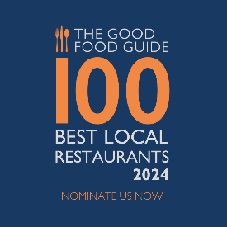
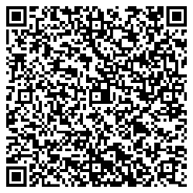
Small plates for sharing

Our small plate menu is freshly prepared and cooked to order.
All small plate dishes will be served as and when ready.

Peppers | Sea Salt
5
Nocerella Olives
5
Ancienne Sourdough | Whipped Butter
5
Hummus | Lemon Tahini | Harissa | Flatbread
8
Scotch Egg | Curry Mayonnaise
9
Hot Wings | Hot Sauce | Green Chilli Slaw
9.5
Burrata | Datterini Tomatoes| Basil | Foccacia
12.5
Ex Dairy Sliders | House Relish | American Cheese
14
Southern Fried Chicken Wrap | Iceberg | Chilli Mayonnaise
13
Tempura Battered Haddock | Mushy Peas | Triple Cooked Chips
16.5
Jumbo King Prawns | Garlic & Herb Butter
18
Whole Grilled Megrim Sole | Caper | Lemon | Parsley Butter
21
500g Sirloin | Garlic Butter | Parmesan & Rocket Salad | Triple Cooked Chips
(minimum of 2 persons)
£56
800g Prime Rib | Garlic Butter | Parmesan & Rocket Salad | Triple Cooked Chips
(minimum of 2 persons)
£80
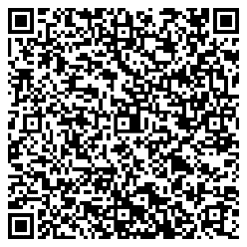
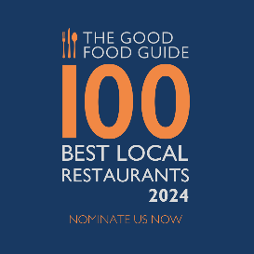
A La Carte
Peppers | Sea Salt 5 Nocerella Olives 5 Sourdough | Whipped Butter 5

2 Courses £28.50 3 Courses £37
Pressed Ham Hock & Parsley Terrine, Chicory Salad & Sourdough
Piri Piri Torched Mackerel, Cucumber, Dill & Yoghurt
Mushroom Tart Fine, Tunworth, Pickled Walnut & Herb Salad
~
New Season Lamb, Shoulder Pastilla, Burnt Aubergine & Yoghurt
Line Caught Cornish Cod, Datterini Tomato, Olive, Jersey Royals & Basil
Spinach & Ricotta Ravioli, English Asparagus, Parmesan & Wild Garlic
500g Sirloin, Garlic Butter, Parmesan & Rocket Salad & Triple Cooked Chips
(£16 supplement minimum of 2 persons)
800g Prime Rib, Garlic Butter, Parmesan & Rocket Salad & Triple Cooked Chips
(£40 supplement minimum of 2 persons)
~
Triple Cooked Chips 5 Truffle Fries | Parmesan 6
Jersey Royals | Chive Butter 6 Tenderstem Broccoli | Chilli | Gar.l.ic 5
BBQ Hispi | Black Garlic | Marmite 5
~
Basque Cheesecake & Blackberry Jam
Hot Chocolate Fondant & Banana Ice Cream
Sticky Toffee Pudding, Toffee Sauce & Vanilla Ice Cream
George IV Cheese Board, Red Onion Marmalade & Sourdough Crackers
(£2.50 Supplement)

