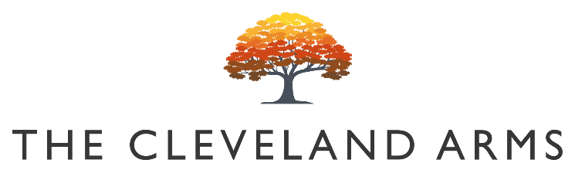
#

(

Bloody Mary’s

Bloody Bens Bloody Mary £5.50

Bloody Bens Large Bloody Mary £8

Bloody Bens Virgin Mary £3

Small Plates

Crispy Fried Prawns
Garlic Aioli £9

Sussex Chorizo Hash
Caramel Onions, Potato & Fried Egg £8

Crispy Korean Style Chicken Wings
Blue Cheese & Celery £8

Chilli & Baby Pepper Houmous
Croutons & Crudites (VG) £7

Macaroni Cheese Bon Bons
Sundried Tomato Chutney & Herbs (V) £7

Warm Autumn Salad
Pesto, Hazelnut & Pickled Beets (VG) £8

Ham Croquettes
Sweet Chilli & Pickles £5

Sides

Triple Cooked Chips £3.50

Herb Marinated Mixed Olives £3.50

Sourdough Bread & Cultured Butter £3.50

Children’s Menu

Any Children’s Size Roast £8

Barfield’s Sausage Roast £8

Barfield’s Sausages
Peas, Triple Cooked Chips £7

Battered Cod
Peas, Triple Cooked Chips £7

Sunday Mains

All our roasts are served with seasonal vegetables, roast potatoes, gravy and Yorkshire pudding

Sussex Dry Aged Beef Rump £15

Slow Roast South Downs Lamb Shoulder £15

Pressed Sussex Pork Belly £14

Free Range Roast Chicken Breast £14

Barfields 6oz Sirloin Steak Roast £22

Beetroot, Squash & Mushroom Wellington (VG) £14

Sunday Sides

Pigs in Blankets / Cauliflower Cheese / Ploughman’s Stuffing Slices / Sage & Onion Stuffing Balls/Roast Potatoes / Vegetables

£ 4

Desserts

Treacle Sponge Cake
Vanilla Ice Cream & Custard £6

Cherry & Blackberry Mess (V) £6

Banana Bread & Butter Pudding
Ice Cream & Custard (V) £6

Caramel Chocolate Cheesecake
Chocolate Crumb & Salted Caramel £7

Autumn Fruit Crumble
Ice Cream & Custard (VG) £7

The Cleveland Cheese Board
Pickled Walnut, Crackers & Fruit Jelly £9

FWIP Ice Cream Machine
Soft Serve Ice Creams & Sorbets Available £3.50

