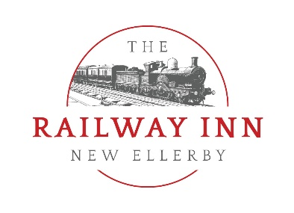

Railway Inn 2022 Buffet Selection

Buffet Option A
- Hot mini beer battered haddock goujons
- Varity of homemade sandwiches & wraps
- Our Butcher’s Luxury Sausages Rolls
- Mixed salad Bowl
- Creamy coleslaw
- Fresh fruit Platter
- Hot homemade proper chips
Option A is at a cost of £10 per person or you can add a Tea & Coffee service for £11.95 per person
Buffet Option B
- Hot mini beer battered haddock goujons
- Varity of homemade sandwiches & wraps
- Our Butcher’s Luxury Sausages Rolls
- Mixed salad Bowl & Creamy coleslaw
- Hot homemade proper chips
- Crudités, hummus & Breads
- Selection of Antipasti cured meats & cheese Platter
Option B is at a cost of £12 per person or you can add a Tea & Coffee service for £13.95 per person

Buffet Option C
- Southern Fried Chicken strips with BBQ dip
- Halloumi Fries with chilli dip
- Haddock Strips with tartare sauce
- Platter of Indian snacks with mint raita and chutneys
- Dirty Loaded Pulled Pork fries
- Chicken Liver Pate with melba toast
Option C is at a cost of £11 per person or you can add a Tea & Coffee service for £12.95 per person

Buffet Option D
- Hot mini beer battered haddock goujons
- Homemade BBQ chicken wraps
- Our Butcher’s Luxury Sausages Rolls
- Mixed salad Bowl & Creamy coleslaw
- Hot homemade proper chips
- Crudités, hummus & Breads
- Selection of Antipasti cured meats & cheese Platter
- Homemade Cheesecake Pots
- Homemade Chocolate Brownies
Option C is at a cost of £14 per person or you can add a Tea & Coffee service for £15.95 per person.

We require a minimum of 30 guests to cater our buffets.

There is a charge of £75 for the private hire of the function room on a Tuesday to Friday.
We charge a fee of £175 for a Saturday day or evening hire.
We charge of £300 on a Sunday for a 3 hour slot for excusive hire of our room.

We are able to cater for different dietary requirements and gluten free options upon request.

We are also able to adapt our menu selections to cater for more vegetarian offering upon request.

Our buffets are suitable for all occasions, from weddings & birthday celebrations, to private meetings and wakes.

If you require any more information please contact our Railway Team on bookrailway@outlook.com or 01964 563770.

Buffet item which can be added at additional charges, or in certain cases swapped and substituted for current choices.

- Halloumi Fries with sweet chilli dip
- Cajun Chicken Tenders
- Cold meat platter with pickles
- BBQ Chicken Wings
- Homemade Quiches
- Smoked Salmon & Seafood platters
- Chicken Liver Pate
- Mozzarella Sticks
- Whitby Scampi

