|  |  |  |  |  |  |  |  |  |  |
| --- | --- | --- | --- | --- | --- | --- | --- | --- | --- |
| P | I | N | E | A | P | P | L | E | B |
| L | I | M | E | C | G | O | D | A | C |
| E | F | G | H | I | R | R | J | P | H |
| M | E | L | O | N | A | A | K | P | E |
| O | R | Q | P | O | P | N | M | L | R |
| N | T | U | V | X | E | G | X | E | R |
| S | T | R | A | W | B | E | R | R | Y |
| B | A | N | A | N | A | Y | Z | J | Q |

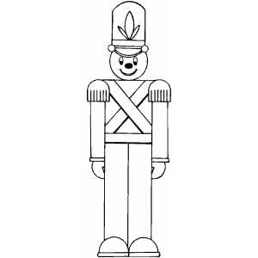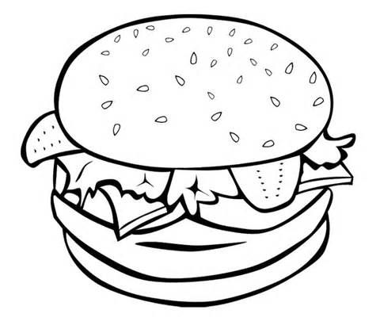 

**The Volunteer**

**Children’s Menu**

Mains

Mini Cheeseburger & Chips

Chicken Dippers & Chips

Fish Fingers & Chips

Veggie Dippers & Chips

Sausages & Chips

All *mains are served with peas or beans*

**£5**

Desserts

Ice Cream Sundae

*Selection of ice cream topped with chocolate or strawberry sauce whipped cream, sprinkles, wafer, and a flake.*

Chocolate Sponge pudding

*Served with custard or vanilla ice cream*

Sticky Toffee Pudding

*Served with custard of vanilla ice cream*

**£3.50**

Find all the fruit in the wordsearch and hand your colouring page to the bar and win a prize!

Apple

Banana

Cherry

Lemon

Lime

Melon

Pineapple

**Find the fruit**

**wordsearch**