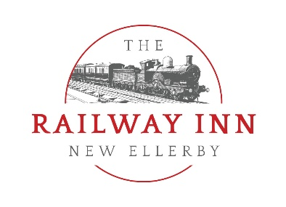

Railway Inn 2021 Buffet Options

Buffet Option A
- Hot mini beer battered haddock goujons
- Varity of homemade sandwiches
- Homemade chicken wraps
- Our Butcher’s Luxury Sausages Rolls
- Mixed salad Bowl
- Creamy coleslaw
- Fresh fruit Platter
- Hot homemade proper chips
Option A is at a cost of £9.95 per person or you can add a Tea & Coffee service for £11.50 per person
Buffet Option B
- Hot mini beer battered haddock goujons
- Varity of homemade sandwiches
- Homemade BBQ chicken wraps
- Our Butcher’s Luxury Sausages Rolls
- Mixed salad Bowl & Creamy coleslaw
- Fresh fruit Platter
- Hot homemade proper chips
- Individual Homemade mini quiches
- Luxury Antipasti Platter with breads, crudités and hummus
Option B is at a cost of £12 per person or you can add a Tea & Coffee service for £13.50 per person
Buffet Option C
- Hot mini beer battered haddock goujons
- Platter of Indian snacks with mint raita and chutneys
- Homemade BBQ chicken wraps
- Our Butcher’s Luxury Sausages Rolls
- Mixed salad Bowl & Creamy coleslaw
- Fresh fruit Platter
- Hot homemade proper chips
- Individual Homemade mini quiches
- Luxury Antipasti Platter with breads, crudités and hummus
- Homemade Cheesecake Pots
- Homemade Chocolate Brownies
Option C is at a cost of £13.95 per person or you can add a Tea & Coffee service for £15.50 per person.

Buffet item which can be added at additional charges, or in certain cases swapped and substituted for current choices.

- Halloumi Fries with sweet chilli dip
- Cajun Chicken Tenders
- Cold meat platter with pickles
- BBQ Chicken Wings
- Smoked Salmon & prawn platters
- Chicken Liver Terrine
- Mozzarella Sticks
- Whitby Scampi

We require a minimum of 30 guests to cater our buffets.

There is a charge of £75 for the private hire of the function room on a Tuesday to Friday.
We charge a fee of £175 for a Saturday day or evening hire.
We charge of £300 on a Sunday for a 3 hour slot for excusive hire of our room.

We are able to cater for different dietary requirements and gluten free options upon request.

We are also able to adapt our menu selections to cater for more vegetarian offering upon request.

Our buffets are suitable for all occasions, from weddings & birthday celebrations, to private meetings and wakes.

If you require any more information please contact Michelle on therailwayoffice@gmail.com or 01964 563770.

