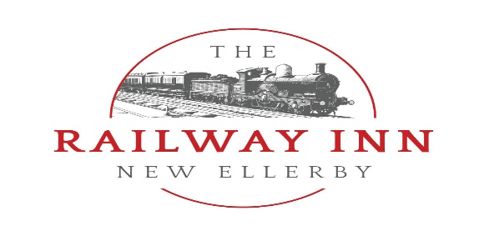

Finger & Fork Buffet Choices 2024
***
A The Railway Basic
A selection of finger sandwiches, homemade wraps (a mix of meat & vegetarian fillings) & proper hot chips £6.50pp
B The Railway Pig
Hog Roast Style Hot Pork Baps, with stuffing, apple sauce & crackling £6.50pp
C The Railway Traditional
Beer battered Fish goujons, homemade quiche, proper hot chips, and selection of wraps (a mix of meat & vegetarian fillings) mixed salad & £12pp
D The Railway Mexican
Beef chilli Nachos, mozzarella sticks, pulled pork cheesy fries, mac ‘n’ cheese bites, salsa, guacamole & sour cream, bowls of tortillas £14pp
E The Railway Mighty Meat
Homemade sausage rolls, southern fried chicken strips, sliced cured meats & cheese platter with crackers, mozzarella sticks & proper hot chips £15pp
***
We also offer bespoke buffet packages, please speak to our kitchen team if you would like to know more information or have any requests.
booktherailway@gmail.com 01964 563770
Our buffet are perfect for any occasion, and are ideal for groups of 30-150pp
Room Hire Fee; £75 Tuesday-Friday
£150 Saturday Day £200 Saturday Night
Sundays are not available for hire

