Drinks List
Wines_______________________________________________
125 ml 175ml 250ml Bottle Champagne & Sparkling

White Prosecco Canti Sensi 18k

The Old Courthouse - Chardonnay – Australia £20.00 £25.00
Tropical fruit flavours complimented by crisp finish

£3.50 £5.00 £7.00 £18.00 Moet Et Chandon £55.00
The Brut Imperial is a dry and elegant champagne
Jack Rabbit - Pinot Grigio - Italy
Fresh, fruity and easy drinking dry white classic Italian

£3.50 £5.00 £7.00 £18.00 Moet et Chandon Ros`e £65.00

Pretty Paddock - Sauvignon Blanc – New Zealand
Layer upon layer of intense gooseberry and grassy flavours

£6.00 £8.00 £24.00

Dos Condores - Sauvignon Blanc – Chile
Crisp and very refreshing, it offers and abundance of grapefruit and tropical flavours

£3.50 £5.00 £7.00 £18.00

Red

Jacob Creek - Shiraz – Australia
Packed with vibrant fruit and full of character

£4.00 £6.00 £7.00 £21.00

Dos Condores - Merlot – Chile
Light plummy notes, ripe berry fruit, smooth and balanced

£3.50 £5.00 £7.00 £18.00

Yellow Tail – Malbec – Australia
Rich and velvety, with notes of ripe berries, dark chocolate and a hint of spice

£3.50 £5.00 £7.00 £18.00

Campo Viejo – Rioja – Spain £24.00
Smooth and velvety with strawberry aromas and hints of vanilla and nuts

Oyster Bay – Pinot Noir – New Zealand £28.00
Elegant, assertive wines with glorious fruit flavours

Ros`e

Marin Hills – White Zinfandel – California
Really good blush, easy drinking with hints of strawberry flavours and a soft finish

£3.50 £5.00 £7.00 £18.00

Three Mills – Pinot Grigio Blush
A delicate dry wine with fresh red berry fruit character

£3.50 £5.00 £7.00 £18.00

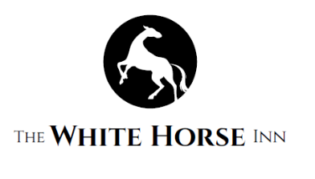

Draught Beer______________________________________
Guinness 4.2% £4.50 Gin________________________________________
Kronenbourg 1664 5.0% £4.50
Fosters 4.0% £4.30 Gordon’s 37.5% £3.00
Birra Moretti 4.6% £5.00 Bombay Sapphire 40.0% £3.00
Thatchers Cider 4.8% £4.50 Hendrick’s 41.4% £3.50
Doom Bar Ale 4.0% £4.00 Plymouth 41.2% £3.00
Guest Ale £4.00 Flavoured Gin’s £3.00
Silent Pool 43.0% £3.00
Bottles_________________________________________ Opihr 40.0% £3.00
Bulmers Original £4.00 Sipsmith 41.6% £3.00
Bulmers Red Berries £4.00
Kopparberg Strawberry and Lime £4.00 Vodka______________________________________
Kopparberg Mixed Fruit £4.00 Smirnoff 37.5% £3.00
Kopparberg Pear £4.00 Absolute – Flavours 40.0% £3.00
Thatchers Katy £4.00 Chekov 37.5% £3.00
Crabbies Ginger Beer £4.00 Grey Goose 40.0% £3.00
Corona Extra £3.00
Desperados £3.00 Whisky_____________________________________
Becks Red £3.00 Southern Comfort 35.0% £3.00
Budweiser £3.00 Famous Grouse 40.0% £3.00
Peroni £3.00 Jameson’s 40.0% £3.00
Cobra 330ml £3.00 Jack Daniels 40.0% £3.00
Brewdog Dead Pony £3.00 Jim Beam 40.0% £3.00
Brewdog Punk IPA £3.00 Haig Club 40.0% £3.00
Hop House £3.00 Johnnie Walker – Black Label 40.0% £3.00
Kingfisher 660ml £5.00 Single Malts £3.00
Cobra 660 ml £5.00
Stella Artois 660ml £5.00 Brandy_____________________________________
Martell 40.0% £3.00
Alcohol Free Bottles______________________________ Courvoisier 40.0% £3.00
San Miguel00 £2.50 Hennessey 40.0% £3.00
Heineken00 £2.50
Becks Blue £2.50
Kopparberg Mixed Fruit £3.00
Rum_______________________________________
Bacardi 37.5% £3.00
Pusser’s Rum 54.5% £4.00
Soft Drinks_____________________________________ Malibu 21.0% £3.00
Coke Tap Pint £3.00 Captain Morgan Dark Rum 35.0% £3.00
Coke Tap Half Pint £2.00 Captain Morgan Spiced Rum 35.0% £3.00
Lemonade Tap Pint £3.00
Lemonade Tap Half Pint £2.00 Liqueur’s__________________________________
Diet Coke Tap Pint £3.00 Tia Maria 20.0% £3.00
Diet Coke Tap Half Pint £2.00 Baileys 17.0% £3.00
Frangelico 20.0% £3.00
Cointreau 40.0% £3.00
Soda & Cordial Tap Pint £1.50 Grand Marnier 40.0% £3.00
Soda & Cordial Tap Half Pint £1.00 Disaronno 40.0% £3.00
Coke Bottle £2.00
Coke Zero Bottle £2.00 Shots_____________________________________
Fanta £2.00 Sours – Flavours £2.00
J2O Orange & Passion Fruit £2.50 Tequila £2.00
J2O Apple & Mango £2.50 Sambuca – Flavours £2.00
J2O Apple & Raspberry £2.50
Appletizer £2.50
Elderflower £2.50
Ginger Beer £2.00
Orange/ Cranberry/ Apple Juice Pint £3.00
Orange/ Cranberry/ Apple Juice Half Pint £2.00
Sparkling Mineral Water £2.00
Still Mineral Water £2.00
Diet Pepsi £1.50
Schweppes Tonic Water £2.00
Schweppes Slimline Water £2.00
Fever Tree Tonic Water £2.00
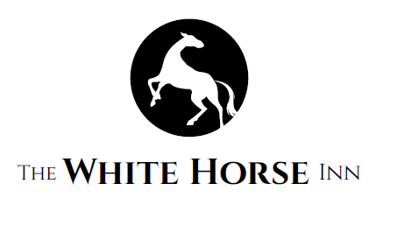
Ginger Ale £2.00
Bitter Lemon £2.00
Fruit Shoot £1.00

