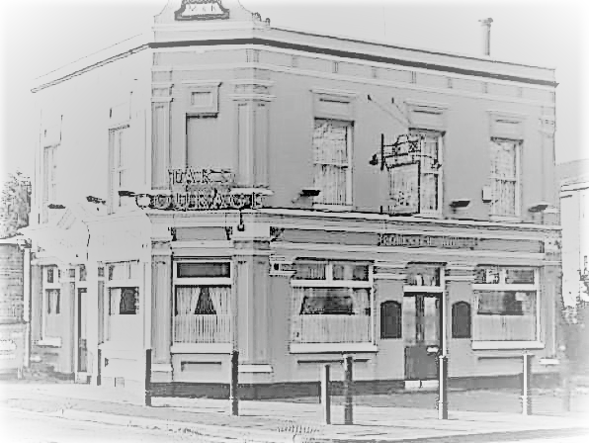
FORESTERS ARMS
SPRING MENU
Fresh Round Rolls from £1.80
Long sub rolls and crusty bread sandwiches £2.20
Chips £1.60 Cheesy Chips £2.20
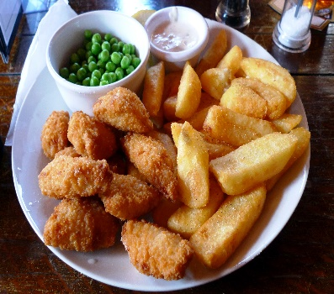
Hot Panini’s
This Photo by Unknown Author is licensed under CC BY-SA
Cheese £2.50
Ham £2.80
Cheese and Ham £3.00
Steak and Onion or Mushroom £3.80
Extras 50p each
MAIN MEALS
Fish Finger Sandwich with chips and side salad £5.00
Breakfast Brunch 2 bacon 2 sausages egg chips beans or tomatoes & crusty bread £6.50
Chicken Curry or Chilli and rice or chips £5.50
Cheese or Ham Ploughman’s with crusty bread and crisps £5.00
3 Egg Omelette with chips and salad £4.50
Scampi and Chips with side salad or Peas £6.00
Ham, 2 Eggs and Chips £5.80
Rump Steak, 2 Eggs Onions rings grilled tomato Mushrooms & Chips £9.80
1/4lb Burger £3.00 with chips £4.20
¼lb Burger with cheese £3.50 with chips £4.70
½ lb Burger £5.50 with chips £6.70
!/2 lb Burger with cheese £6 with chips £7.20
Add Egg for 50p extra
Our special Cheese Board with at least 5 different cheeses £7.50
See our boards for daily specials
CHILDRENS MENU
for under 10 years £3.50
Chicken dippers or fish fingers or Burger or cheeseburger or Ham and Cheese Toasty
All come with chips add Beans for 30p extra. 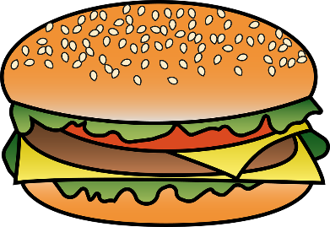
FOOD ALERGY? Please Ask before you eat

