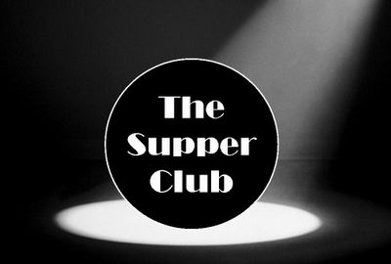
Friday 31st January
7.30pm
£38.95 per person

31text here
@ The Rake & Pikel

Join us on our first supper club evening with a trip to Spain.
Enjoy 5 fantastic courses and a drink to match each course

Selection of Tapas to Start for you all to enjoy
Pork & Beef meatballs in a paprika and tomato sauce
Chorizo & Prawn skewers with Alioli dip
Padron peppers, pan fried with sea salt
Fried Aubergines drizzled with honey
~
Followed by Garlic Soup
~
Mango Sorbet to cleanse the palate
~
For Mains Please choose from one of the following

~Chicken Stew, diced chicken, chorizo, fennel and olives in a smoked paprika and tomato broth with charred garlic brushed ciabatta

~Traditional Paella of chicken and seafood
please let us know in advance if you require this dish

~Pinchos Morunos
Spanish marinated Pork Kebabs with salad and patatas bravas

~Mixed bean, chickpea and sweet potato and kale stew in a rich sweet sherry and paprika sauce and swerved with charred garlic brushed ciabatta
~
To Finish
A sharing desert of cinnamon churros with a rich chocolate dipping sauce
and homemade Spanish Crema Catalana

FOR BOOKINGS PLEASE CALL IN OR RING 01244 351500

