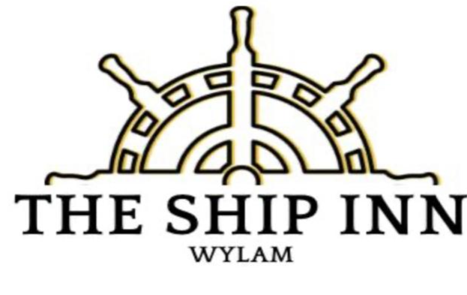
Sunday Lunch @ the Ship Inn Wylam
Starters
Soup of the Day - Warm Bread
Salt & Chilli Calamari – Served with Aloli
Potato Skins– With a Garlic Mayo
Haggis Fritters – With a Garlic Mayo
Creamy Garlic Mushrooms – Served with Warm Breads
Main Courses
Roast Striploin of Beef & Roast Gravy
Roast Turkey & Gravy
Roast Loin of Pork, Crispy Crackling
Slow Roasted Leg of Lamb
Trio of Meats (£21)
(All Of the above served with Roast Potatoes, Mash Potatoes, Yorkshire Pudding, Seasonal Vegetables, Stuffing & Pigs in Blanket)
Pie of the day – Served with Mash & Seasonal Veg.
Vegetable Pie (Vegetarian) – Topped With Cheese & Bread Crumb. Mash Veg & Gravy
Cod & Chips – With Mushy Peas
Deserts
Choice of Deserts (ask waiting staff what’s available)
2 Course £25
3 Course £32

