the white horse | 18th October, 2020
FUSION SUNDAY ROAST |  |  |  | Chefs Special SHARING ROAST  £22.00  Chicken, Pork & Lamb  SERVED WITH SEASONAL VEGETABLES, HONEY ROASTED PARSNIPS, YORKSHIRE PUDDING & MEAT GRAVY (Requested sauce) *  YOUNG ADULT ROAST £7.00  Choice of meat* served with mash or diced veg & roast potato’s along with Yorkshire pudding & gravy  Dessert £4.50  Sticky toffee pudding with clotted ICE cream  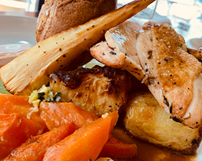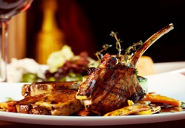

STARTERS

CRISPY ROASTED POPPADOMS £2.50
Served with Hot & Sweet Tamarind Sauce
THREE CHEESE FRESHLY BAKED BREAD £4.50
Cheddar, Mozzarella & Blue Cheese

MAINS

SLOW ROASTED LEMON & THYME BUTTER

CHICKEN £12.50
SERVED WITH SEASONAL VEGETABLES, HONEY ROASTED PARSNIPS, YORKSHIRE PUDDING & MEAT GRAVY

ROASTED PORK LOIN W’ CRACKLING £12.50
SERVED WITH SEASONAL VEGETABLES, HONEY ROASTED PARSNIPS, YORKSHIRE PUDDING & MEAT GRAVY (Apple sauce) *

SLOW BRAISED ROASTED LAMB £12.50
SERVED WITH SEASONAL VEGETABLES, HONEY ROASTED PARSNIPS, YORKSHIRE PUDDING & MEAT GRAVY (Mint Sauce) *

BUTTER NUT & LENTIL ROAST £12.00
SERVED WITH SEASONAL VEGETABLES, HONEY ROASTED PARSNIPS, GRAVY

