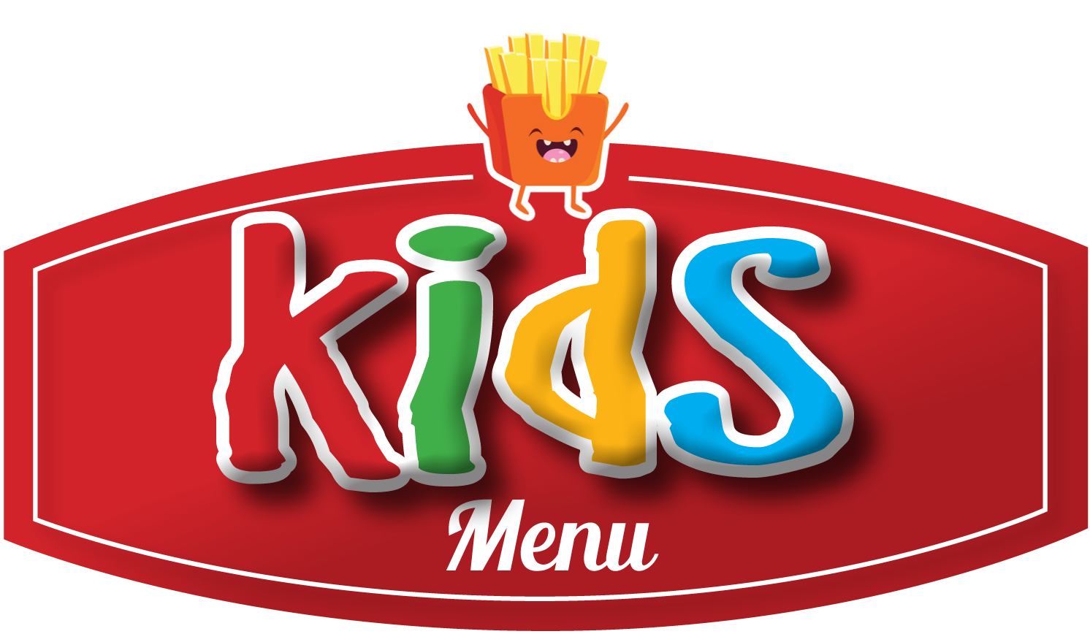
ALL kids’ menus are at a price of £ 5.50

- Sausage, Chips, Garden Peas OR Beans & Gravy

- Cheesy Mac & Cheese with Garlic Bread

- Battered Cod Goujons, Chips & Garden Peas OR Beans

- Breaded Chicken Goujons, Chips & Garden Peas OR Beans

- Margherita Pizza, Chips & Salad

Please ask for a selection of ice cream for ONLY £ 2.50
