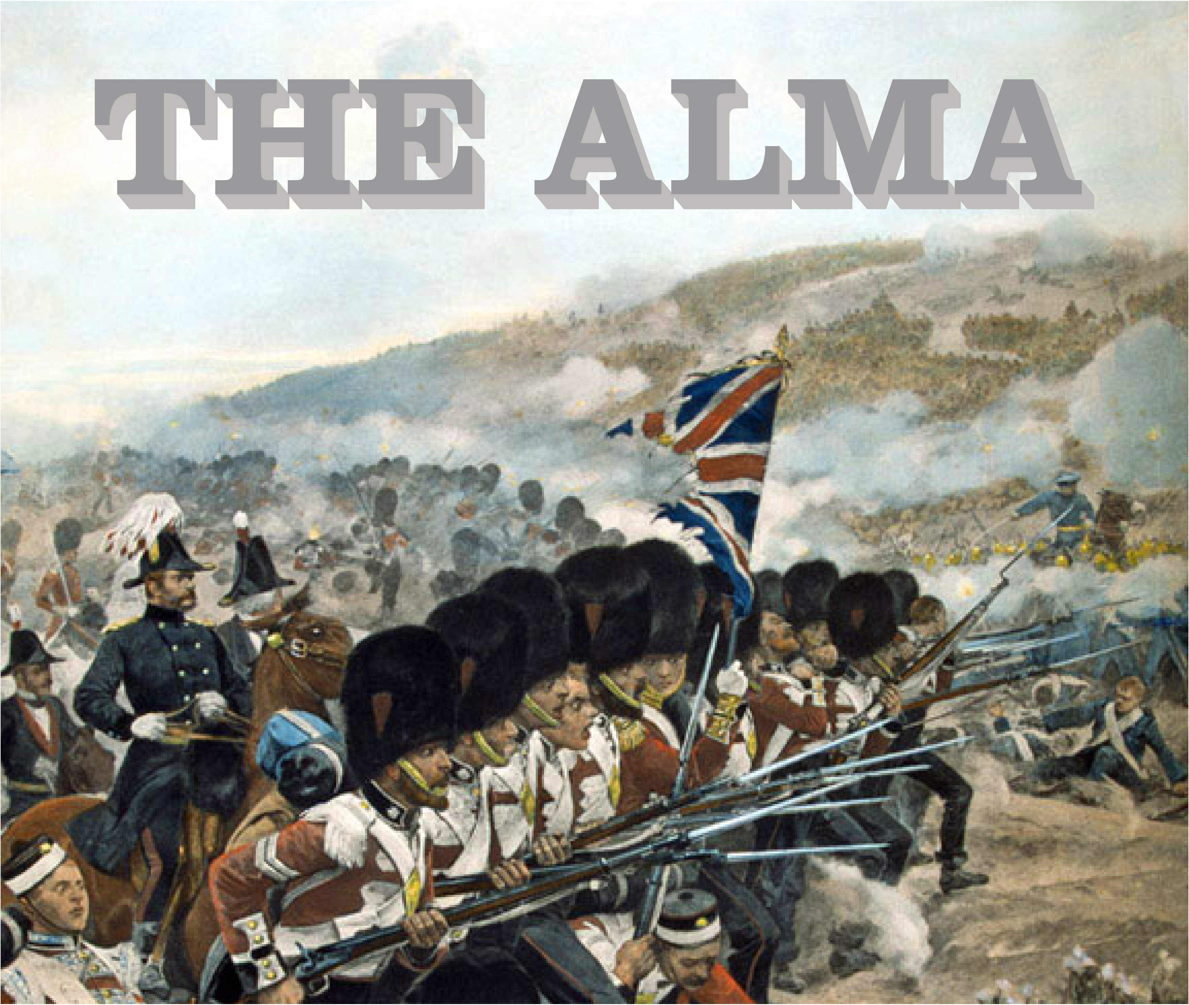
SPRING LUNCH TIME MENU
Served from 12pm-2pm Monday to Friday

All food is made fresh to order and at busy times your order can take around 20 minutes, if you are in a rush then unfortunately your food will not come any quicker. If you are a group of 5 or more then we kindly ask you to all order at the same time and not individually, if it helps you can always call/email your order to us.

SANDWICHES
TOASTED CHEESE SANDWICH (V) (one filling) 7.90
SANDWICH (V) (one filling) choice of ham, cheese, sausage, bacon, fish finger
or fried egg 7.90
All sandwiches can be served on white or brown and all come with skin on fries

MAINS
SOUP OF THE DAY (V) Served with bread and butter 4.50
JACKET POTATO (V) Served with butter & two fillings (see below to add more) 7.50
SAUSAGE or HAM, EGG & (skin on) FRIES with peas or beans, the name says it all 7.50
THE ALMA OMELETTE with a choice of two fillings served with fries and salad 7.50
SCAMPI & (skin on) FRIES Served with side salad and lemon wedge 7.80
RONNIE’S HOMEMADE LASAGNE Served with (skin on) fries and side salad 7.80
PLOUGHMANS Cooked ham & mature cheddar with pickle, pickled onions,
bread and butter 7.50

SANDWICH & JACKET POTATO EXTRAS
ham, cheese, bacon, beans, salad, fried egg 1.20
tuna, spag bol, chili or sausage 1.40
SIDES
Skin on fries 3.50, cheesy fries 4.00, cheesy fries with jalapenos 4.50, side salad 3.50, onion rings 3.00
DESSERTS
Ask for today’s offering
If you have any allergies or intolerances, then please do let us know. As some of our dishes may contain allergens, we cannot guarantee that our food is allergen free. (V) vegetarian friendly.

Keep up to date with what is happening at The Alma:
Facebook, The Alma Pub Sidcup, Instagram, TheAlmaPubSidcup, W: www.thealmapub.co.uk, T: 020 8300 3208 E: info@thealmapub.co.uk
The Alma, 10 Alma Road, Sidcup, Kent, DA14 4EA

