Welcome to

The Lord Nelson Inn
at Besthorpe

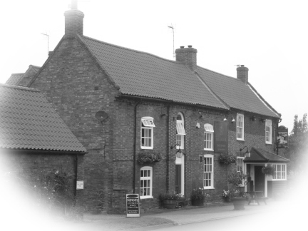

Richard, Margaret, and Joan extend a warm welcome to all customers old and new.

Please make your choices from the menu and place your order at the bar.

All of our meals are cooked to order, please be patient particularly during busy times.
Starters

Soup of the Day £3.85
Served with a crusty roll.

Duck and Port Pâté £4.35
A traditional pâté, served with toast.

Prawn Cocktail £4.60
Prawns in a Marie-rose sauce on a bed of salad leaves, served with brown bread.

Smoked Mackerel £4.60
Smoked mackerel with lemon and parsley, served on a bed of salad leaves with horseradish sauce.

Garlic Mushrooms £4.60
Deep-fried crispy coated mushrooms, served with a garlic mayonnaise dip.

Oriental King Prawns £4.60
Tiger prawns wrapped in filo pastry, deep-fried and served with a sweet chilli dip.

Spicy Chicken £4.60
Spicy chicken wings served with a barbecue sauce.

Brie Wedges £4.60
Breaded brie wedges, deep-fried and served with redcurrant jelly.

Mains

All main courses are served with a choice of chips, cheddar mash, or new potatoes, and fresh vegetables of the day, or if you prefer, a salad.

Rump Steak £9.75
8oz rump steak cooked to your liking and served with mushrooms and onion rings.

Sirloin Steak £13.75
10oz sirloin steak cooked to your liking and served with mushrooms and onion rings.

Ribeye Steak £13.75
10oz ribeye steak cooked to your liking and served with mushrooms and onion rings.

Why not have a sauce with your steak?

Creamy Stilton Sauce £1.50
Cracked Black Peppercorn Sauce £1.50
Brandy and Mushroom Sauce £1.75

Gammon Steak £8.95
10oz horseshoe gammon steak, served with grilled pineapple and a fried egg.

Pork Fillet £9.75
Pan-fried medallions of pork with a honey and mustard sauce.

Cajun Chicken £9.75
Cajun-spiced chicken breast fillet served with a hot salsa.

Chicken & Stilton £9.75
Chicken breast fillet served with a creamy stilton cheese sauce.

Beef & Guinness Pie £8.75
Tender beef and Guinness pie with a shortcrust pastry lid.

Lamb Shank £10.75
Delicious lamb shank in mint gravy.

Salmon Fillet £10.75
A poached fillet of salmon, served with a lemon and dill sauce.

Plaice £8.75
Deep-fried breaded plaice served with tartare sauce.

Scampi £8.75
Breaded whole-tail scampi, served with tartare sauce.

Brie, Potato, Courgette & Almond Crumble £8.75
A thick creamed Brie sauce with layers of potato and courgette topped with a breadcrumb,
almond, cheese, sesame seed and parsley crumble.

Sweet Potato, Chickpea & Spinach Curry £8.75
Served with pilau rice, poppadums and mango chutney.

Creamy Cheese & Broccoli Bake £8.75
Broccoli florets and potato slices in a creamy cheese sauce.

Please see the blackboards for our daily specials and selection of desserts.

