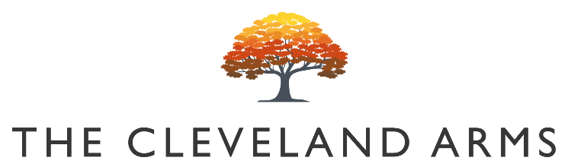
#

(

Bloody Mary’s

Bloody Bens Bloody Mary £5.50
With Wild Mary Vodka £6.50

Bloody Bens Large Bloody Mary £8
With Wild Mary Vodka £9

Bloody Bens Virgin Mary £3

Small Plates

Spring Vegetable Minestrone (Vg)
Asparagus, Peas & Sourdough Bread £7

Salmon & Cod Fishcakes
Chilli, Crème Fraiche & Watercress £9

Sprouting Broccoli & Feta Tart (Vg)
Toasted Pine Nuts & Dressed Herbs £8

Baked Egg & Chorizo Shakshuka
Beans, Peppers & Tomato £8

Baked Cornish Truffled Brie (V)
Toasts, Pickles, Chutney £12

Prawn Cocktail
Marie-Rose Sauce £8

Herb Marinated Mixed Olives £3.50

Sunday Sides

Pigs in Blankets / Truffle Cauliflower Cheese / Veggie Stuffing / Pork Stuffing / Roast Potatoes / Vegetables

£ 4

Children’s Menu

Any Children’s Size Roast £8

Barfields Sausage, Roast Potatoes & Greens £8

Sunday Mains

All our meat & vegan roasts are served with seasonal vegetables, roast potatoes, gravy, and Yorkshire pudding.

Roast Rump of Beef £15

Slow Roast South Downs Lamb Shoulder £15

Roast & Rolled Sussex Pork Belly £14

Sussex Free Range Roast Chicken Supreme £14

Vegan Puy Lentil, Kale & Sweet Potato Wellington (Vg) £14

Vegetarian Option available

Skate Wing Roast £15
Caper Butter

Desserts

Warm Lemon & Dark Chocolate Yoghurt Cake
Chocolate Sauce & Ice Cream (V) £5

Gooseberry Fool
Cream & Lemon Shortbread (V) £6

Baked Chocolate Cookie Skillet (V)
Vanilla Ice Cream & Chocolate Sauce £7

Almond Frangipane (Vg)
Apricot & Honeycomb Crunch £7

The Cleveland Cheese Board (V)
Pickled Walnut, Crackers & Fruit Jelly £9

FWIP Ice Cream Machine
Soft Serve Ice Creams & Sorbet Available £3.50

