Badger Hounds Christmas Fayre Menu
We are proud to source all our meat from R. Lyth & Son, Hinderwell & our bread from Beech Grove Bakery, Runswick Bay.
Please let us know if you have any food allergies or special dietary requirements.
This menu will be served between the 1st & 30th of December on Wednesday, Thursday, Friday & Saturday evenings only.

Starters

Roast Parsnip Soup - £ 6.95 (GF) (V) (VE)
Toasted Sourdough drizzled with Local Honey, Parsnip Crisps

Hendricks Cured Salmon - £8.95 (GF)
Pickled Cucumber, Toasted Sourdough Crostini, Dressed Leaves

Potted Ham Hock – £ 7.95 (GF)
Rosemary Butter, Crispy Crackling, Apple & Pineapple Relish

Sauteed King Scallops – £8.95
Crispy Black Pudding Fritter, Cauliflower Puree

Mains

Roast Turkey Breast Wrapped in Streaky Bacon - £ 14.95 (GF)
Beef Dripping Roast Potatoes, Sage, Pork & Apricot Stuffing, Creamed Potatoes, Seasonal Veg & Homemade Gravy

Rolled Local Belly Pork - £ 14.95 (GF)
Crispy Crackling, Creamed Potatoes, Butternut Puree, Seasonal Veg, Rosemary & Cider Cream

Seared Hake Fillet - £ 14.95 (GF)
Roast Garlic Potatoes, Sauteed Wild Mushrooms, Kale, Red Wine & Thyme Sauce

Homemade Vegetable & Yorkshire Blue Nut Roast - £ 13.95 (V) (VE)
Roast Potatoes, Creamed Potatoes, Seasonal Veg & Homemade Vegetarian Gravy

Desserts

Strawberries & Cream Cheesecake - £ 6.95
Strawberry Ice Cream, Strawberry & Basil Coulis

Deconstructed Eton Mess - £ 6.95 (GF)
Chantilly Cream, Vanilla Ice Cream

Double Chocolate Brownie - £ 6.95
Biscoff Crumb, Chocolate Sauce, Vanilla Ice Cream

Sticky Toffee Rum Pudding - £ 6.95
Honeycomb, Butterscotch Sauce, Vanilla Ice Cream

Selection of Yorkshire Cheese & Crackers - £ 8.95 (GF)
Red Onion Marmalade, Grapes & Apple

Sides

Twice Cooked Chunky Chips - £2.95
Beer Battered Onion Rings - £2.95
10 inch Garlic Flatbread - £5.95
10 inch Cheesy Garlic Flatbread - £ 6.95
Homemade ‘Slaw - £1.50
Peppercorn/ Diane/ Yorkshire Blue Sauce - £2.95
House Salad - £2.95
Seasonal Panache of Vegetables - £2.95
Mac & Cheese - £ 4.95

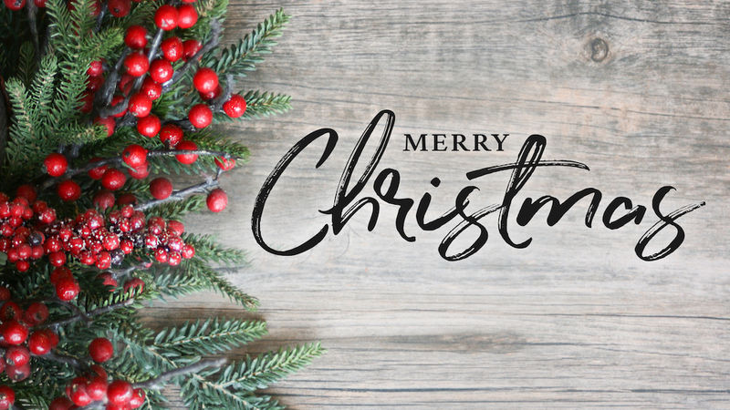

Wishing You & Your Beloved a very Merry Christmas & a Happy New Year!

Please make your table reservation by sending us an email, we DO NOT take reservations via social media.

The Badger Hounds
39, High Street
Hinderwell
TS135JX
Tel.: 01947841730
E-mail: thebadgerhounds@gmail.com
www.badgerhounds.co.uk

