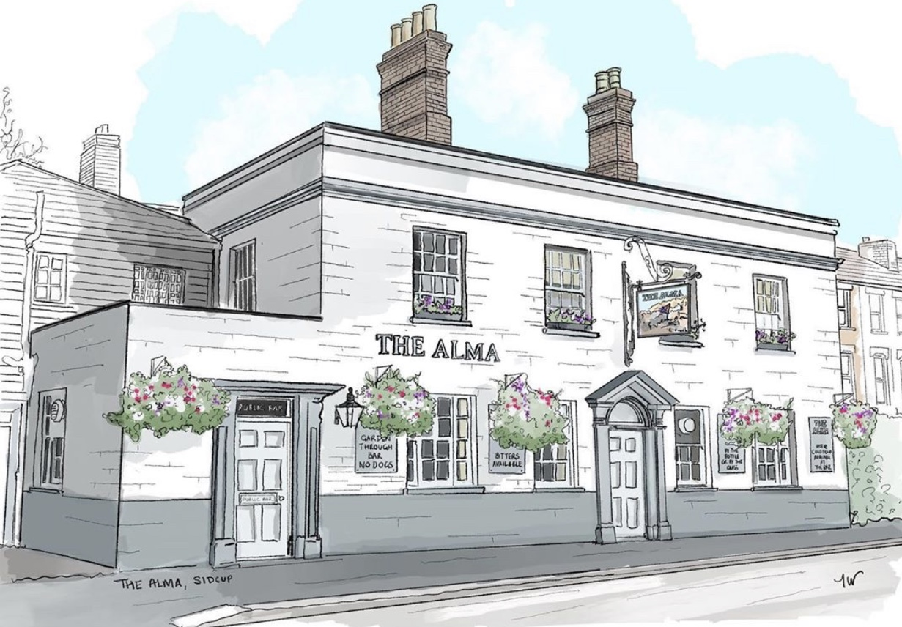
LUNCH TIME MENU
Served from 12pm-2pm Monday to Friday

All of our food is made fresh to order and at busy times your order can take around 20/25 minutes, if you are in a rush then unfortunately your food will not come any quicker. If you are a group of 5 or more then we kindly ask you to all order at the same time and not individually, if it helps you can always call/email your order to us.

Sandwiches
All served with crisps and a salad garnish with a light french dressing, choice of white or brown bread
Chicken / Tuna mayo (can add sweetcorn) 4.90
Prawn mayo 4.90
Cheese & pickle / Ham & mustard 4.50
Toasties
on white or brown 4.00
Cheese toastie (v) with a choice of ham, tomato (v) or onion (v)
Jacket Potatoes
with butter and grated mature cheddar (v)
with a choice of Heinz beans (v) or tuna mayo 4.00
Soup
Soup of the day (V) Served with bread and butter 2.50
If you have any allergies or intolerances, then please do let us know. As some of our dishes may contain allergens, we cannot guarantee that our food is allergen free. (v) vegetarian friendly, (ve) vegan friendly.

Keep up to date with what is happening at The Alma:
Facebook: The Alma Pub Sidcup, Instagram: TheAlmaPubSidcup, Twitter: TheAlmaSidcup W: www.thealmapub.co.uk,
E: info@thealmapub.co.uk, 10 Alma Road, Sidcup, Kent, DA14 4EA
LUNCH TIME MENU
Served from 12pm-2pm Monday to Friday

All of our food is made fresh to order and at busy times your order can take around 20/25 minutes, if you are in a rush then unfortunately your food will not come any quicker. If you are a group of 5 or more then we kindly ask you to all order at the same time and not individually, if it helps you can always call/email your order to us.

9” stuffed crust pizzas, 7.00 each
BBQ meat feast with a cheese stuffed crust
Cheddar & mozzarella cheese feast with a cheese stuffed crust (v)
Ultimate garlic & cheese with a cheese stuffed crust (v)
Double pepperoni pizza with a cheese stuffed crust
Cheese and tomato pizza with a hot dog stuffed crust
New Yorker, fried onions, salami, sweet mustard sauce with a hot dog stuff crust
Add jalapenos (v) 50p
Light bites
Bacon roll, Cheese & pickle roll 2.50
Chips 3.50, Cheesy chips 4.00
Ask for today’s specials

If you have any allergies or intolerances, then please do let us know. As some of our dishes may contain allergens, we cannot guarantee that our food is allergen free. (v) vegetarian friendly, (ve) vegan friendly.

Keep up to date with what is happening at The Alma:
Facebook: The Alma Pub Sidcup, Instagram: TheAlmaPubSidcup, Twitter: TheAlmaSidcup W: www.thealmapub.co.uk,
E: info@thealmapub.co.uk, 10 Alma Road, Sidcup, Kent, DA14 4EA

