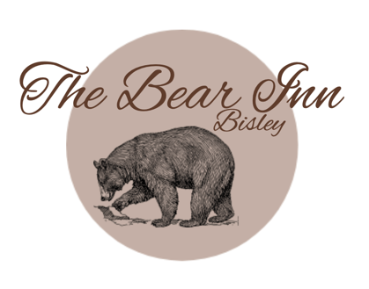

Sunday Lunch

Starters
'Real' Mixed Olives to share (VG)(GF) 5

Rustic bread rolls for 2,4 or 6 people 5/6/8

Salt and Pepper Squid, fresh coriander and Caesar dressing 8

The Bear Inn classic cheese soufflé, double Gloucester cheese, fresh creamy chives (GF)(V) 9

Smoked Ham Hock Terrine, fig & apple chutney, sourdough 9

We offer a variety of Sunday roasts, all our meats are from our fantastic butcher, Ruby & Whites from Bristol.
All our roast lunches are served with Koffman roast potatoes, honey glazed parsnips & carrots, red cabbage, cauliflower 3 cheese, mixed greens, stuffing and of course a Yorkshire and red wine Gluten free gravy!
(Vegetarian gravy is available on request)

Mains £17.50
Please choose from the following:
Roast beef
Roast pork
Chicken supreme
Nut roast (V) (VE)
Under 6’s small plate roast with a scoop of ice-cream to follow £12.50

Desserts
Bourbon Vanilla Crème Brulé and shortbread biscuit (GFO) (V) 8

Brioche Apple Tart and honeycomb ice cream (V) 8

Raspberry crumble tart & raspberry coulis with custard/cream/ice cream (V) 8

Warm chocolate & toffee brownie with vanilla ice-cream (V) 8

Winter Mess – meringue, winter poached fruit, coulis and whipped cream (GF) (V) 8

Kids ice - cream 2.95

*All booking reservations are for 1hr 30 minutes, we sincerely apologise for this but due to our limited table numbers and popularity of our Sunday roasts we have had to include a time limit.

The Bear Inn is not an allergen free kitchen, our produce may come into contact with any of the 14 recognised allergens, if you have an allergy or intolerance, please notify a member of staff so that they may advise you on what our dishes contain. Items are marked on the menu as Gluten Free
(GF), Vegetarian (V)(VO) or Vegan (VE)(VGO)

Prices include VAT. Your bill will have a discretionary 10% service charge.

