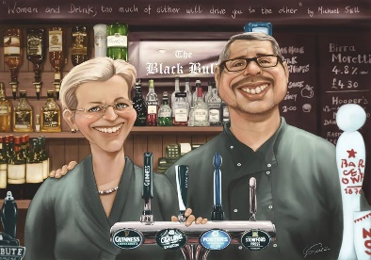
THE SWAN INN
Call 01296714404 to place your order
Breakfast Menu served 9-11a.m.
FULL ENGLISH BREAKFAST £8.95
2x Bacon, Sausage, Hash Brown, Baked Beans, 2 x Fried Eggs, Mushrooms, a Grilled Tomato, Black Pudding & Fried Bread.
BREAKFAST BAGUETTES £5.95
Including butter
Choose 3 from the following: -

Bacon, Sausage, Egg , Mushrooms, Onions, Hash Browns & Black Pudding

