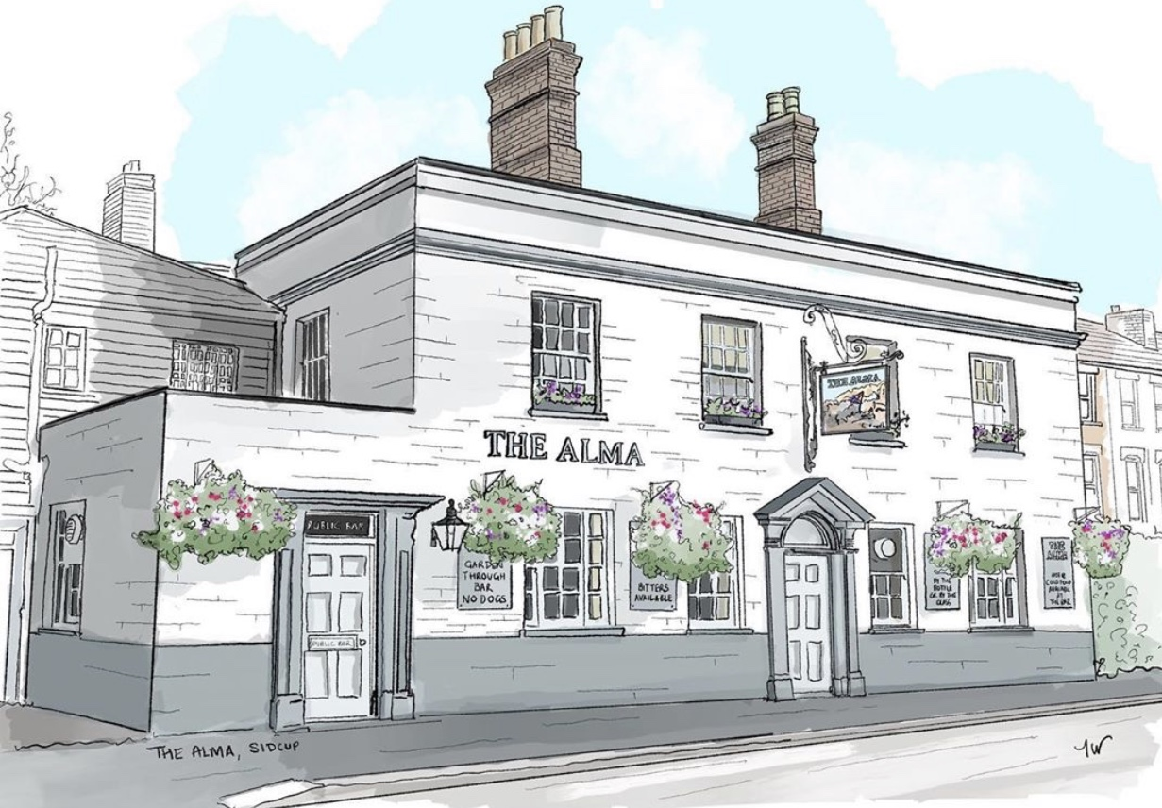
LUNCH TIME MENU
Served from 12pm-2pm Monday to Friday

All of our food is made fresh to order and at busy times your order can take around 20/25 minutes, if you are in a rush then unfortunately your food will not come any quicker. If you are a group of 5 or more then we kindly ask you to all order at the same time and not individually, if it helps you can always call/email your order to us.

Sandwiches/Baguettes
All served with crisps and a salad garnish with a light french dressing, choice of freshly baked baguette (allow up to 15 mins), thick white tiger bread or
thick sliced Hovis brown bread
Tuna mayo (can add sweetcorn) / Prawn mayo / Fish finger 4.90,
Beef & horseradish / Cheese & pickle / Ham & mustard 4.50
Hot dog with ketchup and mustard & fried onions 4.50
All available in a half baguette for £2.50
Toasties
All served with a salad garnish and a light french dressing, on thick white tiger bread or thick sliced Hovis brown
Cheese toastie 4.00 (v) with ham 4.20, with tomato or onion 4.10 (v)
cheese, ham, tomato and onion 4.30
Jacket Potatoes
with butter and grated mature cheddar (v)
with a choice of Heinz beans (v) 4.00, Tuna mayo (can add sweet corn) 4.50,
Prawn mayo 4.50, homemade spicy chilli con carne 4.50
Soup
Soup of the day (V) Served with bread and butter 3.00
If you have any allergies or intolerances, then please do let us know. As some of our dishes may contain allergens, we cannot guarantee that our food is allergen free. (v) vegetarian friendly, (ve) vegan friendly.
LUNCH TIME MENU
Served from 12pm-2pm Monday to Friday

All of our food is made fresh to order and at busy times your order can take around 20/25 minutes, if you are in a rush then unfortunately your food will not come any quicker. If you are a group of 5 or more then we kindly ask you to all order at the same time and not individually, if it helps you can always call/email your order to us.

9” stuffed crust pizzas, 7.00 each
BBQ meat feast with a cheese stuffed crust
Cheddar & mozzarella cheese feast with a cheese stuffed crust (v)
Ultimate garlic & cheese with a cheese stuffed crust (v)
Double pepperoni pizza with a cheese stuffed crust
Cheese and tomato pizza with a hot dog stuffed crust
New Yorker, fried onions, salami, sweet mustard sauce with a hot dog stuff crust
Add jalapenos (v) 50p
Mains
Pie on its own 3.50, with chips and gravy 6.50
Scampi and chips served with a lemon wedge and a salad garnish with a light french dressing 6.50
Lasagne with a salad garnish and chips 6.50
Spicy lasagne with a salad garnish and chips 6.50
Sides
Chips 3.50, Cheesy chips 4.00, Cheesy jalapeno chips 4.50

If you have any allergies or intolerances, then please do let us know. As some of our dishes may contain allergens, we cannot guarantee that our food is allergen free. (v) vegetarian friendly, (ve) vegan friendly.

