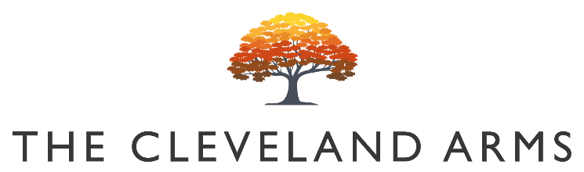

Bloody Bens Bloody Mary £5.50

Bloody Large Bloody Mary £8

Bloody Bens Virgin Mary £3

Small Plates

Duck Liver and Port Parfait
Focaccia toasts and gooseberry chutney £7

Local Chorizo, Bean and Feta Stew
Focaccia bread and local feta £8

Chickpea and Paneer Madras
Fresh onion salad and mint soya yoghurt (V) £7
Vegan option available

Sharing Baked “Boy Laity” British Camembert
Focaccia & Balsamic Onions (V) £12

Sunday Mains

All our roasts are served with seasonal vegetables, roast potatoes, gravy and Yorkshire pudding

Rare Breed South Downs Beef Rump £14.50

Slow Roast Rolled Lamb Shoulder £14

Slow Roasted Pork Shoulder £13

Free Range Roast Chicken £13

Beetroot, Puy Lentil, & Celeriac Wellington (VG) £12

Sides

Pigs in Blankets / Cauliflower Cheese / Pork Stuffing / Roast Potatoes / Vegetables £4

Children’s Menu

All our children’s meals (except roasts) are served with triple cooked chips £6

Half Portion of Any Roast £8

Battered Line Caught Cod

Desserts

Flourless Chocolate Cake
Salted caramel and vanilla ice cream (V) £6

Sticky Toffee Pudding
Popcorn and Amaretto Ice Cream (V) £7

Rhubarb Upside Down Cake
Custard and vanilla ice cream (V) £7
Vegan Option Available

Children’s Half Portion Available

Cheese Board
Selection of 3 Local Cheeses, Crackers, Pickles & Chutney (V) £8

3 scoop Ice Cream Selection £3

Ice Cream Cone £2

Vegan Ice Cream Available

