#
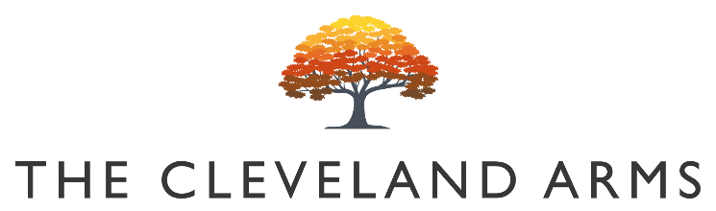

(

Bloody Bens Bloody Mary £5.50

Bloody Bens Large Bloody Mary £8

Bloody Bens Virgin Mary £3

Small Plates

Hand Picked Crab Cakes
Sweet Chilli, Pea Shoots & Preserved Lemon £9

Toasted Sesame & Pepper Houmous
Croutons & Crudités (VG) £7

Crispy Korean Style Chicken Wings
Blue Cheese & Celery £8

Honey & Mustard Glazed Chipolatas
Honey Mustard Dip & Mustard Seeds £7

Sourdough Bread & Cultured Butter (V) £3.50

Herb Marinated Mixed Olives (V) £3.50

Sunday Mains

All our roasts are served with seasonal vegetables, roast potatoes, gravy and Yorkshire pudding

Sussex Dry Aged Beef Rib-eye £15

Slow Roasted Lamb Shoulder £15

Sussex Pork Belly £14

Free Range Chicken Breast £14

Beetroot, Squash & Lentil Wellington (VG) £14

Pan Fried Sea Bream
Crushed New Potatoes, Tenderstem
Broccoli, Dill Cream Sauce £14

Sides

Pigs in Blankets / Cauliflower Cheese / Pork Stuffing / Roast Potatoes / Vegetables £4

Children’s Menu

Half Portion of Any Roast £8

Battered Line Caught Cod & Chips £7

Desserts

Fwip gelato, sorbet, frozen yoghurt £3.50

Warm Blackberry & Chocolate Pudding
Vanilla Ice Cream (V) £5.50

Apple & Blackberry Crumble
Vanilla Ice Cream (V) £7

Burnt Peach Upside Down Cake
Vanilla Ice Cream & Cherries (VG) £6
Summer Berry Eton Mess
Meringue & Ice Cream (V) £7

The Cleveland Cheese Board
Pickled Walnut, Crackers & Fruit Jelly (V) £9

