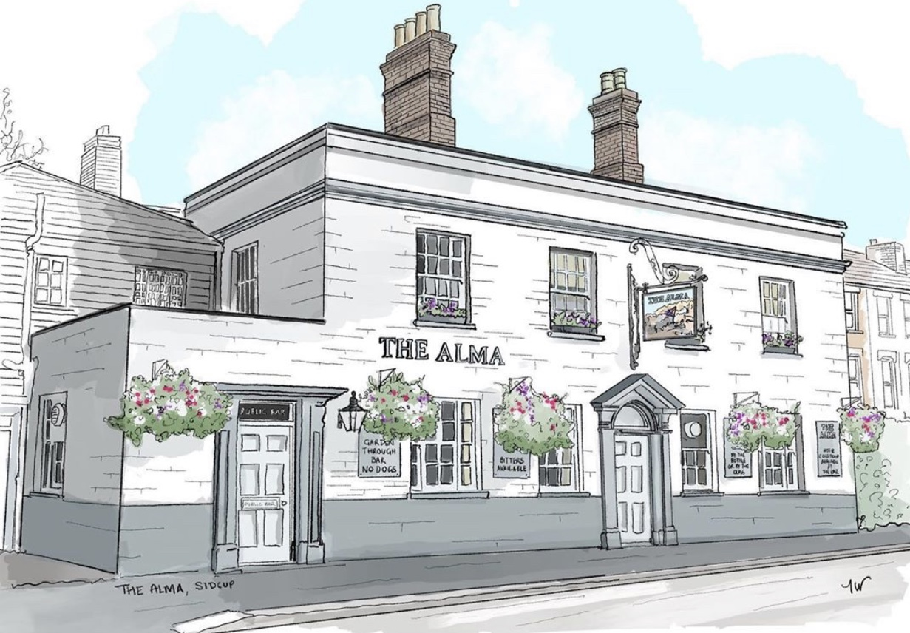
THE ALMA LUNCH MENU
Served from 12pm-2:30pm Monday to Friday

Smaller Bites

Soup of the day (ve) Served with bread and butter 3.90
Mains
Scampi and chips served with a lemon wedge and a salad garnish 8.00
Beer battered cod fillet and chips served with a lemon wedge and a salad garnish 8.50
Homemade pie and chips 8.00, ask for today’s filling
Cumberland Sausages, mash and onion gravy 8.50
The Alma omelette, cheese, ham, cherry tomatoes & peppers (v) 6.80
Plain omelette, just egg (v) 5.00, Cheese or Ham omelette (v) 6.00
Homemade beef lasagne served with chips or salad 8.50
Crispy chicken caesar salad 8.00
The Alma burger in a sesame topped bun, homemade beef pattie or chicken Milanese with Hellmann’s mayo, lettuce, tomato, onion & gherkin, both served with chips 8.50
(£1 extra for cheese)
Sandwiches/Baguettes
All sandwiches (not including hot dog or steak baguette)
are served with crisps and a salad garnish with salad dressing, choice of thick sliced tiger
or thick sliced Hovis brown bread or a freshly baked sourdough baguette for 1.00 extra
Fish finger 5.00 / Tuna mayo 5.50 / Tuna mayo sweetcorn 6.00
Prawn mayo 7.50, Cheese & pickle (v) / Ham & mustard 4.50
Cumberland sausages with caramelized onion, mustard & mayonnaise 7.50
Hot dog baguette with fried onions, single 6.50, double 8.50
Steak baguette with caramelized onion, mustard & mayonnaise 8.50

If you have any allergies or intolerances, then please do let us know. As some of our dishes may contain allergens, we cannot guarantee that our food is allergen free. (v) vegetarian friendly, (ve) vegan friendly.

Paninis
All served with a salad garnish and salad dressing on panini
Cheese panini 4.50 (v) with ham or with tomato or onion 5.00 (v),
Tuna mayo, sweetcorn and red onion 6.50
Chicken Milanese, lettuce, tomato and mayonnaise 7.50
Sausage, tomato, mustard and mayo 7.50
Jacket Potatoes
with butter and grated cheddar & mozzarella (v)
Just cheese or Heinz beans (ve) 6.00, Heinz beans & cheese (v) 6.50
Tuna mayo & cheese 6.50, Tuna mayo, sweetcorn and cheese 7.00
Prawn mayo & cheese or homemade spicy chilli con carne with cheese 7.50
Dirty Chips
Cheese 4.00, cheese and jalapeños 4.50, chili con carne with cheese & garlic mayo 6.50
Side Dishes
Chips 3.50, garlic bread (ve) 3.50, cheesy garlic bread (v) 4.00, gravy 1.00, Heinz beans (ve) / mushy peas (ve) / peas (ve) 2.00, greens with garlic and chili (ve) 3.50, beer battered onion rings 4.50, spaghetti with homemade tomato sauce (ve) 4.00
Desserts & Hot Drink
All desserts are served with either double cream or custard

Sticky toffee sponge, Spotted dick, Golden syrup sponge, Strawberry jam sponge 4.50
Chocolate melt in the middle pudding 5.00

Pot of tea for 1, 3.00
Café au lait intense or espresso 3.50

All of our food is made fresh to order in our 5 star rated kitchen and at busy times your order can take around 20/25 minutes, unless otherwise stated on the menu, if you are in a rush then unfortunately your food will not come any quicker. If you are a group of 3 or more then we kindly ask you to all order at the same time and not individually, if it helps you can always call/email your order to us.

All of the meat products that we use are from The Butchers (formerly Potters) on 8 St Johns Parade, Sidcup, DA14 6ES
If you have any allergies or intolerances, then please do let us know. As some of our dishes may contain allergens, we cannot guarantee that our food is allergen free. (v) vegetarian friendly, (ve) vegan friendly.
THE ALMA LUNCH MENU
Served from 12pm-2:30pm Monday to Friday

Smaller Apetites Menu
All of the following are smaller in portion and are only £5 each

Spaghetti and homemade tomato sauce 5.00
Chicken milanese with spaghetti & homemade tomato sauce 5.00
Cheese or Ham omelette 5.00
Scampi and chips served with a lemon wedge and a salad garnish 5.00
Jacket potato with beans and cheese, just cheese or tuna 5.00
Sandwich or toastie 5.00
Homemade ham croquettes 5.00
Soup of the day 3.90

Desserts & Hot Drink
All desserts are served with either double cream or custard

Sticky toffee sponge, Spotted dick, Golden syrup sponge, Strawberry jam sponge 4.50
Chocolate melt in the middle pudding 5.00

Pot of tea for 1, 3.00
Café au lait intense or espresso 3.50

All of our food is made fresh to order in our 5 star rated kitchen and at busy times your order can take around 20/25 minutes, unless otherwise stated on the menu, if you are in a rush then unfortunately your food will not come any quicker. If you are a group of 3 or more then we kindly ask you to all order at the same time and not individually, if it helps you can always call/email your order to us.

All of the meat products that we use are from The Butchers (formerly Potters) on 8 St Johns Parade, Sidcup, DA14 6ES

If you have any allergies or intolerances, then please do let us know. As some of our dishes may contain allergens, we cannot guarantee that our food is allergen free. (v) vegetarian friendly, (ve) vegan friendly.

