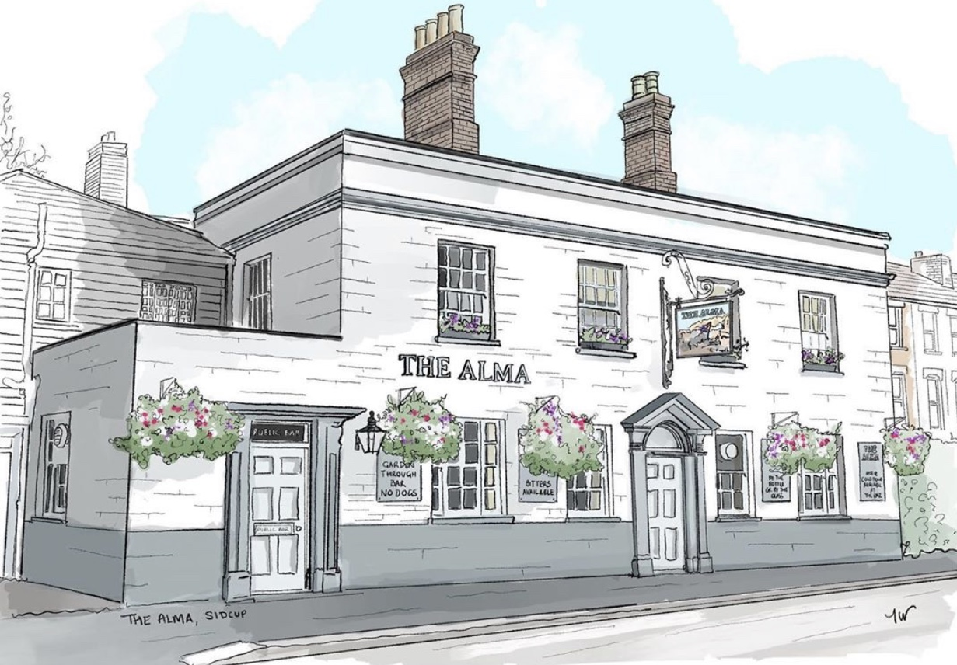
LUNCH TIME MENU
Served from 12pm-2pm Monday to Friday

We are running a restricted menu at the moment, please do bear with us as we will be bringing other menu items back over the coming weeks. All of our food is made fresh to order and at busy times your order can take around 20 minutes, if you are in a rush then unfortunately your food will not come any quicker. If you are a group of 5 or more then we kindly ask you to all order at the same time and not individually, if it helps you can always call/email your order to us.

Pies
£5.00 with mash
Steak & ale, chicken & mushroom, vegetable wellington (v) or keralan vegan curry pasty (v)
Toasties
£4.00 on white or brown
Cheese toastie (v) with a choice of ham, tomato (v) or onion (v)
Jacket Potatoes
£4.00 with butter and grated mature cheddar (v)
with a choice of Heinz beans (v) or tuna mayo

If you have any allergies or intolerances, then please do let us know. As some of our dishes may contain allergens, we cannot guarantee that our food is allergen free. (V) vegetarian friendly.

Keep up to date with what is happening at The Alma:
Facebook: The Alma Pub Sidcup, Instagram: TheAlmaPubSidcup, Twitter: TheAlmaSidcup W: www.thealmapub.co.uk,
T: 020 8300 3208 E: info@thealmapub.co.uk, 10 Alma Road, Sidcup, Kent, DA14 4EA

LUNCH TIME MENU
Served from 12pm-2pm Monday to Friday

We are running a restricted menu at the moment, please do bear with us as we will be bringing other menu items back over the coming weeks. All of our food is made fresh to order and at busy times your order can take around 20 minutes, if you are in a rush then unfortunately your food will not come any quicker. If you are a group of 5 or more then we kindly ask you to all order at the same time and not individually, if it helps you can always call/email your order to us.

Pizzas
£9.00 each
Four cheese & balsamic red onion (V)
Spicy chicken & chargrilled red pepper
Buffalo mozzarella & sun soaked tomatoes (V)
Spicy salami & red chili
Lighter Snacks
Red Leicester, mature cheddar & balsamic red
onion flatbread (v) £2.00
Basil Pesto & Tomato flatbread (v) £2.00
Garlic & parsley ciabatta slice (v) £2.00
Caramelised garlic & extra virgin olive oil 9” flatbread (v) £2.50

Please allow up to 15 minutes for your pizza to be cooked. If you have any allergies or intolerances, then please do let us know. As some of our dishes may contain allergens, we cannot guarantee that our food is allergen free. (V) vegetarian friendly.

Keep up to date with what is happening at The Alma:
Facebook: The Alma Pub Sidcup, Instagram: TheAlmaPubSidcup, Twitter: TheAlmaSidcup W: www.thealmapub.co.uk,
T: 020 8300 3208 E: info@thealmapub.co.uk, 10 Alma Road, Sidcup, Kent, DA14 4EA

