STARTERS

SOUP OF THE DAY - £3.80
SERVED WITH BABY BAGUETTE & BUTTER

POTATO SKINS (V)
SINGLE - £4.00 DOUBLE - £6.00

POTATO SKINS TOPPED WITH RED ONION, CHEESE SERVED WITH SWEET CHILLI DIP & SOUR CREAM

ADD JALAPENOS
SINGLE - 50p DOUBLE - £1.00

PRAWN COCKTAIL £4.00
WITH HOMEMADE MARIE ROSE SAUCE

BAKED GOATS CHEESE - £4.50
GLAZED WITH BALSAMIC VINEGAR & SERVED WITH TOASTED CIABATTA & SALAD

MUSHROOM RISOTTO BALLS - £4.00
SERVED WITH ROCKET & PARMESAN SALAD WITH A SPICY TOMATO SAUCE

BLACK PUDDING - £4.95
IN A LIGHT BATTER SERVED WITH CREAM POTATO, CRACKLING, CRISPY BACON & PEPPER SAUCE

COASTAL CATCH

SEASIDE FISH & CHIPS
SMALL - £5.75 STANDARD - £9.00 WHALE - £12.50

COATED IN A REAL ALE BEER BATTER. SERVED WITH HAND CUT CHIPS & A CHOICE OF MUSHY PEAS, GARDEN PEAS OR SALAD

GOURMET WHOLE TAIL SCAMPI
SMALL - £6.00 STANDARD - £9.50 LARGE - £13.00

COATED IN A REAL ALE BEER BATTER, SERVED WITH HAND CUT CHIPS & A CHOICE OF MUSHY PEAS, GARDEN PEAS OR SALAD

SPICY COD BITES
SMALL - £5.75 STANDARD - £9.00

COD COATED IN A CAJUN AND REAL ALE BEER BATTER SERVED WITH RICE, SWEET CHILLI DIP & SALAD

HALF A KILO* OF MUSSELS - £8.50
STEAMED IN A WHITE WINE, GARLIC & CREAM SAUCE, FRESH CORIANDER SERVED WITH HAND CUT CHIPS & BABY BAGUETTE

SEAFOOD PLATTER - £13.00
CALAMARI, COD BITES, SCAMPI SERVED WITH HAND CUT CHIPS, SALAD & A SELECTION OF DIPS

HONEY SALMON - £9.00
SALMON FILLET POACHED IN HONEY
SERVED WITH GARLIC RICE & SALAD

PUB CLASSICS

HOMEMADE LASAGNE
MEAT OR VEGETARIAN (V)
SMALL - £5.75 STANDARD - £9.00

SERVED WITH GARLIC BREAD & SALAD

SAUSAGE & MASH - £9.00
2 LARGE SAUSAGES SERVED WITH COLCANNON MASH, RED ONION GRAVY & A SIDE OF VEGETABLES

GARLIC CHICKEN - £11.00
SERVED WITH STIR-FRY VEGETABLES & RICE

SWEET AND SOUR CHICKEN
SMALL - £5.75 STANDARD - £8.50

CHUNKS OF CHICKEN BREAST BATTERED IN REAL ALE BATTER SERVED WITH RICE & CHEF’S OWN SWEET & SOUR SAUCE

LAMBS LIVER AND BACON
SMALL - £5.75 STANDARD - £8.50

SERVED WITH A RICH ONION GRAVY & A STACK OF SEASONAL VEGETABLES & MASH

MINCE & DUMPLINGS
MEAT OR VEGETARIAN (V)
SMALL - £5.75 STANDARD - £8.50

SERVED WITH MASHED POTATO & A STACK OF SEASONAL VEGTABLES.

8oz* PORK LOIN STEAK - £10.00
SERVED WITH APPLE MASH, GREEN BEANS & SAGE GRAVY

SUET PUDDING - £12.00
DO YOU HAVE A BIG APPETITE? A LARGE STEAK & MUSHROOM SUET PUDDING SERVED WITH BLACK PUDDING MASH & POACHED LEEKS

PIE OF THE WEEK - £8.50
ASK STAFF FOR DETAILS – SERVED WITH HANDCUT CHIPS & GARDEN PEAS OR MASHED POTATO & VEGETABLES

3
FROM THE GRILL

10oz* SIRLOIN STEAK - £13.00
A SUCCULENT STEAK SERVED WITH HAND CUT CHIPS, GRILLED MUSHROOMS & TOMATO

WHY NOT ADD ONION RINGS? - £1.50

GAMMON STEAK
COOKED ON THE GRIDDLE.
SERVED WITH HAND CUT CHIPS & SALAD GARNISH.

5oz* (ONE EGG OR PINEAPPLE RING) - £5.75

10oz* (TWO EGGS OR PINEAPPLE RINGS) - £10.00

MIXED GRILL- £15.00
5oz* SIRLOIN STEAK, 5oz* GAMMON STEAK, CHICKEN BREAST, SAUSAGE, BLACK PUDDING, SERVED WITH HAND CUT CHIPS, GRILLED MUSHROOMS & TOMATO

KINGS HANDMADE BURGER- £9.00
6oz* BEEF / MEAT FREE BURGER (V) IN A TOASTED BUN WITH BEEF TOMATO SLICE, ONION RINGS, HANDCUT CHIPS & SALAD GARNISH.

MAKE IT YOUR OWN & ADD:
CHEESE - 50P
MUSHROOMS – 50P
BACON - £1.00

ADD ALL THREE - £1.50

SANDWICHES

CHEESE & PICKLE - £3.50 (V)
SALMON & CUCUMBER - £3.50
HAM & TOMATO - £3.50

SERVED ON YOUR CHOICE OF BREAD
WHITE, BROWN, OR GRANARY.

WHY NOT ADD
A CUP OF HOMEMADE SOUP - £2.50
A BOWL OF HANDCUT CHIPS - £2.25

BAGUETTES

POSH FISH FINGERS & TARTAR SAUCE - £5.50

GARLIC CHICKEN & MAYONNAISE - £5.50

SERVED ON A FRESHLY BAKED BAGUETTE WITH SALAD

WHY NOT ADD HANDCUT CHIPS? - £1.75.

PANINIS

BACON & BRIE - £5.50
BBQ CHICKEN MELT - £5.50
GOATS CHEESE & RED ONION - £5.50 (V)

SERVED ON FRESHLY BAKED CIABATTA & SALAD.

WHY NOT ADD HANDCUT CHIPS? - £1.75

SIDE ORDERS

HANDCUT CHIPS – £2.25

REAL ALE ONION RINGS – £2.25

SIDE SALAD – £2.25

GARLIC BREAD – £2.25

DON’T FORGET TO CHECK OUT OUR BLACKBOARD FOR TODAYS SPECIALS

DESSERTS

ALL OUR SPONGES, CAKES, & CRUMBLES ARE HOMEMADE. TAKE A LOOK AT OUR DESSERT BOARD FOR TODAYS CHOICES.
MINT CHOCOLATE CHIP, RUM&RAISIN &CHOCOLATE
CHILDREN’S MENU AVAILABLE ON REQUEST

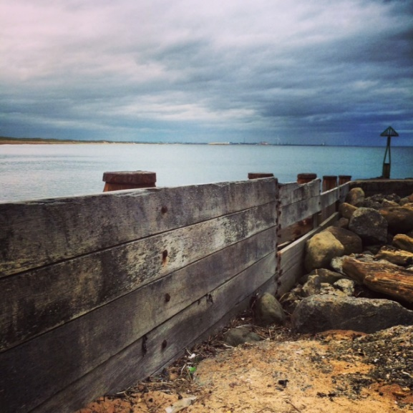

4

