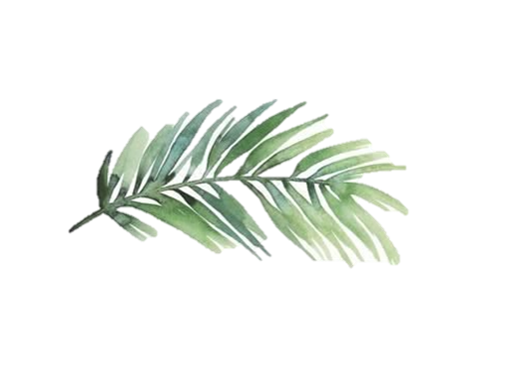
Dyke Neuk Inn Sunday Menu 12-6PM
Three Course Special £19.95
Starters
Homemade Soup of The Day Served with Homemade Olive & Fresh Rosemary Focaccia Bread £5.00 (V)
Baked Garlic & Thyme Whole Brie, Baby Leaf Salad, Served with Red Onion Chutney & Bread Sticks £7.00 (V)
Pan Fried Creamed Garlic Mushrooms Served on Homemade Toasted Sourdough Bread
£6.00 (V) Coconut Milk (VG)
Craster Smoked Kipper Pâte with Toasted Croutons & Dressed Side Salad
£7.00
Potato Skins Served with BBQ & Garlic Dipping Sauces
£6.00 (V)
Northumberland Goats Cheese with Caramelised onions and Fresh Rocket Salad
£7.50 (V) (GF)

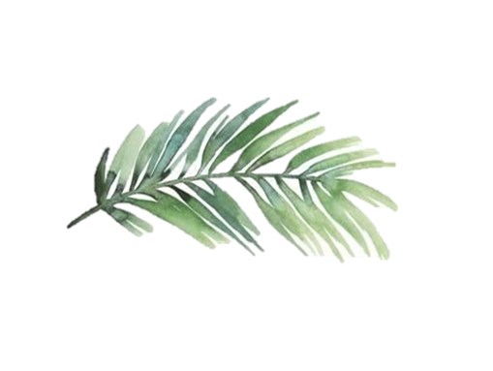
Sunday Lunch Mains
Traditional Sunday Roast Served with all the Trimmings.
A choice of today’s Meats £12.95 - Trio £15.95 - For Lamb add £1.00
Add cauliflower cheese for an extra £3.00
Beer Battered Fillet of Fish £12.95
Served with Hand Cut Chips, Mushy or Garden Peas and Homemade Tartar Sauce
1/2lb Homemade Aberdeen Angus Beef Burger £11.95
Served with French Fries, Homemade Coleslaw, Beer Battered Onion Rings, Relish, Lettuce & Tomato
Add a Topping for £2.00 Choose from Cheese, Bacon or Pulled Pork
Catch of The Day
Please See Board for the Fish of the Day
Vegetable Wellington £12.95 (v)
Carrot & cashew Nuts in Spiced Marmalade, Laced in Garlic & White Wine Sauce, Served with Herb Baby Potatoes & Steamed Vegetables
Vegetarian Roast of the Day £12.95 (v)
Served with Vegetarian Sausage & Yorkshire Pudding
Sweet Potato, Spinach & Feta Lasagne £12.95 (v)
Served with Hand Cut Chips and Garlic Bread & Dressed Side Salad
Homemade Aberdeen Angus Beef Lasagne £12.95
Served with Homemade Chips, Garlic Bread & Dressed Side Salad
Vegan Dish of The Day £12.95
Please See Board for the Dish of The Day (vg)
Soup with an Open Sandwich £9.95
Soup of The Day & Open Sandwich on White, Wholemeal Farmhouse Bloomer Bread or Gluten free and Side Salad. With a choice of Fillings. Please Ask for Todays Fillings

Children’s Menu £5.95
Ages up to 12 years old
Cheeseburger, Fries, Beans or Peas
Beef Lasagne, Fries, Garlic Bread
Chicken Nuggets, Fries, Beans or Peas
Teddy Bear Pizza, Fries, Beans or Peas
Fish Fingers, Fries, Beans or Peas
Roast of The Day
Desserts £6.50
Please See our Desserts Board for Todays Specials

