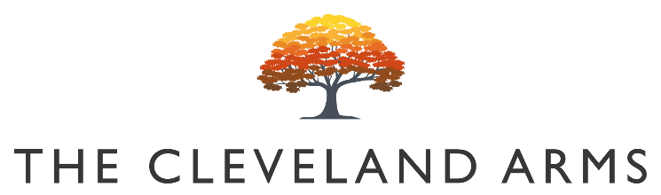

Small Plates

Smoked Ox Cheek Nuggets
Garlic Mayo & Pickled Red Onion £7

Baby Beetroot & Vegan Feta Salad
Pickled Walnut & Wild Rocket (VG) £6

Whipped Smoked Mackerel Pate
Pickled Cucumber & Sourdough Crisp £7

Local Chorizo, Bean & Feta Stew
Focaccia Bread & Local Feta £8

Baked ‘Boy Laity’ British Camembert
Focaccia & Balsamic Onions (V) £6

Sunday Mains

All our roasts are served with seasonal vegetables, roast potatoes, gravy and Yorkshire pudding

Rare Breed South Downs Beef Rump £14.50

Slow Roast Rolled Lamb Shoulder £14

Roast Rolled South Downs Pork Belly £13

Free Range Roast Chicken £13

Beetroot, Squash & Cheddar Wellington (VG) £12

Pigs in Blankets / Cauliflower Cheese / Pork Stuffing £4

Sides

Triple Cooked Chips £3.50

Triple Cooked Chips & Cheese £5.00

Herb Marinated Mixed Olives £3.50

Children’s Menu

All our children’s meals (except roasts) are served with triple cooked chips £6

Half Portion of Any Roast

Battered Line Caught Cod

Homemade Ice Cream Selection £3

Ice Cream Cone £2

Vegan Ice Cream Available

Desserts

Vegan Chocolate Beetroot Fudge Brownie
Chocolate Sauce & Vanilla Ice Cream (VG) £6

Sticky Toffee & date Pudding
Popcorn & Amaretto Ice Cream (V) £7

Baked Vanilla Apple Crumble
Custard & Vanilla Ice Cream (V) £6

Cheese Board
Selection of 3 Local Cheeses, Crackers, Pickles & Chutney (V) £8

Children’s Half Portion Available

