Breakfast Menu  Large Breakfast £6  2 eggs, 2 sausages, 2 bacon, black pudding, hash brown, beans, grilled tomato, toast tea/coffee  Small Breakfast £4  1egg, 1 sausage, 2 bacon, hash brown, beans, grilled tomato, toast, tea/coffee  Sandwiches/butties £2.50  sausage, bacon, egg, cheese, beans on toast  Breakfast drinks  Tea, coffee, J2O, coke, water | The Galley @ The Ship and Mitre  Liverpool’s favourite pub is now serving breakfasts. From 9am Friday, Saturday and 10am Sunday come and start your day right with a large breakfast for just £6!!!!  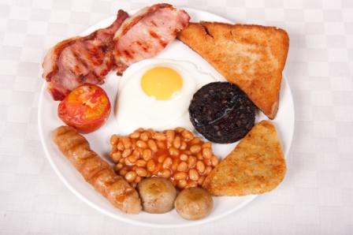  133 Dale street  L2 2JH  0151 236 0859  Follow us on Twitter - @Theshipandmitre  Add us on Facebook – ShipAndMitre Liverpool  Other offers  Every Wednesday at 5pm we have “Scouse on the house”, a free taster of our famous homemade Scouse, remember as its first come first served, be early as it’s really tasty and popular.  PIE & PINT NOW ONLY £5.00 Any of our quality Peninsular Pork Pie’s & a pint of kaltenberg, scrumpy jack, real ale 4%  Meals  Posh sausage, chips, gravy and mushy peas £6.50 (3 free range pork sausages)  Fish, chips and mushy peas £6.50  Steak pie chips gravy and mushy peas £6.00  Scouse £6.50  Tortilla Wrap or Ciabatta  Served with a side salad, add chips for £1  Panko wrap – Panko chicken goujons with sweet chilli sauce - £5.50  Jerk wrap – Chicken goujons with mayo - £5.50  BLT: crispy grilled bacon with lettuce, tomato & mayonnaise - £5.00  Tuna mayo - £5.00  Meals  Posh sausage, chips, gravy and mushy peas £6.50 (3 free range pork sausages) Fish, chips and mushy peas £6.50  Steak pie chips gravy and mushy peas £7.00  Scouse £6.50  Sides  Garlic Ciabatta - £1.50  Garlic Ciabatta with cheese £2.00  Chips - £2.00  Chips &gravy - £2.50  Cajun chips - £2.50  Beer battered onion rings £1.50  Onion bhajis £2.50  Halloumi £4.00  Chicken goujons panko or jerk with dip £4.00  Dips- mayo, sweet chilli, bravas, bbq, , sour cream 50p each  Nachos  Mango Chutney (v) - £6.00  Beef Chilli - £7.50  Butties  Chips - £2.00  Cheese & tomato - £2.00  Bacon-£2.50  Sausage-£2.50  Handmade Burgers  Beef  Classic –£6.50  Cheese –£7.00  Spanish - £7.50  Mexican –- £7.50  Black & Blue – £7.00  BBQ –-£8.00  Chicken  Panko chicken – £7.50  Cajun –£7.50  Fillet –£7  Vegetarian  Halloumi –£6.50  Bhaji –£6.50  Pies  Pork and apple - £3.00  Pork and pickle - £3.00  Plain pork - £3.00  Steak Pie - £3.50  All served with salad, add chips for £1

