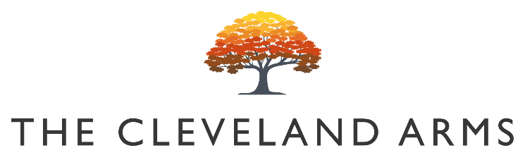
#

(

`

Bloody Mary’s

Bloody Bens Bloody Mary £5.50

Bloody Bens Large Bloody Mary £8

Bloody Bens Virgin Mary £3

Small Plates

Tomato & Mozzarella Arancini Balls (V)
Roasted red pepper salsa & herb oil £7

Ham Hock Terrine
Onion chutney, Cornichon, bread £9

Baked Cornish Truffled Brie (V)
Toasts, pickles & chutney £12

Herb Marinated Mixed Olives £3.50

Sunday Sides

Pigs in Blankets / Cauliflower Cheese / Pork & Apple Stuffing

£ 4

Children’s Menu

Any Children’s Size Roast £8

Tomato Linguine Pasta (V) £7

Sunday Mains

All our meat & vegan roasts are served with seasonal vegetables, roast potatoes, gravy, and Yorkshire
pudding.

Sussex Rump of Beef £15

Slow Roast South Downs Lamb Shoulder £15

Sussex Slow Roast Pork Belly £14

Sussex Free Range Roast Chicken Supreme £14

Roasted mushroom filled butternut squash with herb crumb
(Vg/V) £14

Desserts

Apple & Ginger Crumble (V)
Vanilla Gelato £7

Banana cake with fudge sauce (V)
Vanilla Ice Cream £6

Coffee Affogato (Vg)
Espresso, ice cream, shortbread £5

The Cleveland Cheese Board
Pickled walnut, crackers & fruit jelly £9

FWIP Ice Cream Machine
Soft Serve Ice Creams & Sorbet Available £3.50
Vegan Ice Cream Available

