Christmas Day Menu
2 course £55.00 / 3 course £60.00
Children £24.99 under 5 £9.00

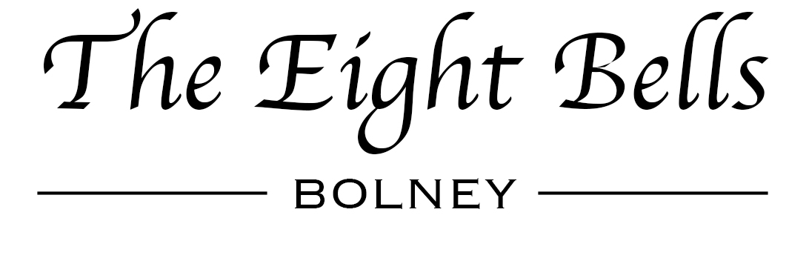
STARTERS

Roasted Parsnip & Crispy Bacon Soup
Served with Fresh Warm Bread

Thyme Infused Baked Camembert
Served with Warm Breads & Sun kissed Tomatoes

Classic King Prawn Cocktail
Topped with Cucumber, Seafood Sauce & Farmhouse Bread

Creamy Garlic Mushroom
Chunky Mushrooms Served with Toasted Ciabatta

Duck & Orange Pate
Served with Leaves, Homemade Chutney & Warm Breads

MAINS

Classic Roast Turkey
Hand Carved with Roasted Parsnips, Carrots & Glazed Winter Greens, Sage & Onion Stuffing
with Cumberland Pigs in Blankets

Venison Steak
Served with Triple Cooked Chips, Confit Beef Tomato & Wild Flat Mushroom
With a Red Wine Jus or a Peppercorn Sauce

Grilled Halibut
Topped with King Prawn Served with Dauphinoise Potatoes in Creamy White Wine Sauce Finished with Crispy Kale

Spinach & Ricotta Cannelloni
Baked & Served with Fresh Salad & Garlic Bread

Vegetarian Nut Roast
A Rich Nut Roast Made with Cashews, Almonds & Mushrooms Topped with Juicy Cranberries & Chestnuts
Served with Roast Potatoes, Carrots, Glazed Winter Greens with Sage & onion Stuffing

DESSERTS

Christmas Pudding with Brandy Sauce
Fruits of The Forest Cheesecake
Traditional Sherry Trifle
Chocolate Fudge Cake
Tiramisu
Lemon Cheesecake
Cheeseboard

