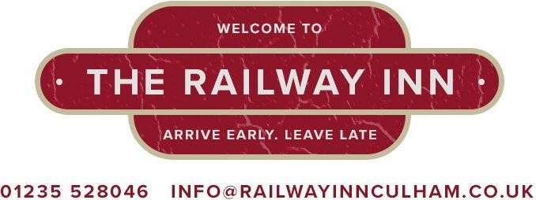

Pauline, Roy and the Staff welcome you

Day | Hours
Monday | 12:00 –14:30 and 18:00 - 20:30
Tuesday | 12:00 - 14:30 and 18:00 – 20:30
Wednesday | 12:00 – 14:30 and 18:00 – 20.30
Thursday | 12:00 – 14:30 and 18:00 – 20:30
Friday | 12:00 – 14:30 and 18:00 – 20:30
Saturday | 12:00 – 14:30 and 18:00 – 20:30
Sunday | 12:00 – 14:30

No food served Sunday Evening
Breakfast served 6:00 - 9:00 Tuesday to Friday
Breakfast served Weekends and Monday 7:00 – 9:00
www.railwayinnculham.co.uk

Starter
Prawn Cocktail |  | £ 5.50
Vegetable Soup |  | £ 4.95
Mushrooms in Garlic Butter (GF) |  | £ 5.25
White Bait (GF) |  | £ 5.25

Light Bites £5.25
Mussells in a Tomato, Chorizo, Paprika Sauce and Bread
Chicken Skewers, Sweet Chilli Dip and Salad
Pork Belly Bites, Apple Sauce and Salad
Lemonsole Fish bites GF, Fries and Tartare Sauce

Burgers
Chilli Garlic Burger £6.50
Hot’n’Spicy Chicken with Pan Fried Pineapple £6.50
Beef Burger GF with Salad GF £6.50
Bowl of Chips or Fries £2.50
Add Cheese £ .50p

Main
Served with Chips, Fries, Mash or New Potatoes, Vegetables
or Salad
Cottage Pie (Homemade and Gluten Free) | £10.95
Lasagne, Peas or Salad and Garlic Bread | £10.95
Chicken Balti, Rice, Puppodum and Chutney | £10.25
Chilli, Rice and Garlic Bread | £10.25
Cod, Chips and Peas | £10.50
Scampi, Chips and Peas | £10.25
Ham, Egg, Chips, Peas or Beans | £10.25
Morrocan Cauliflower Roulade (GF and V) | £ 9.50

Steaks
Served with Chips, Mushrooms, Onion Rings and Peas
Mixed Grill £16.50
Sirloin £14.50
Gammon, Egg or Pineapple £12.50
Peppercorn or Diane Sauce £ 1.50

Dessert
Served with Custard, Cream or Ice Cream
Apple Lattice Pie £ 4.85
Rhubarb Crumble £ 4.95
Sticky Toffee £ 4.85
Bread and Butter £ 4.95
Scoop of Ice Cream 90p

Liquor Coffee £5.25
Tia Maria, Baileys, Whisky, Brandy or Rum topped
With Cream

Children Menu all at £4.95
Sausage, Egg, Fries and Beans or Peas
Ham, Egg, Fries and Beans or Peas
Pasta with Meatballs in Tomato and Herb Sauce
Chicken Nuggets, Fries, Beans

