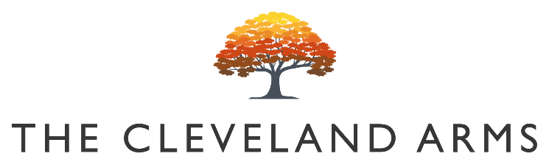
#

(

`

Bloody Marys
Bloody Bens Large Bloody Mary £9.50
Bloody Bens Large Bloody Maria £10
Bloody Bens Virgin Mary £5

Children’s Menu

Any Children’s Size Roast £8

Battered Halloumi V
Crispy Fries, Cucumber £7

Burger & Fries £7

Battered Haddock & Fries £7

Ice Cream
£2

Childrens Rocky Road Sundae V £3

Desserts

Apple & Cranberry Crumble V
Vanilla Ice Cream or Custard £8

Lemon Posset V
Pink Pepper Shortbread & Strawberry £8

Sticky Toffee Pudding V
Salted Caramel Sauce, Vanilla Ice Cream £8

GBC Cheeseboard V
Chutney & Artesian Crackers £10

Small Plates

Olives Vg £4
Rosemary & Lemon

Focaccia Bread V/Vg £6
Cultured Butter & Olive Oil

BBQ Chicken Wings £9
Blue Cheese Dip, Celery

Ham Hock Terrine £8
Onion Chutney & Toast

Sunday Roasts
All our meat & vegetarian roasts are served
with roasted seasonal vegetables, roast potatoes, gravy, and Yorkshire pudding.

Roast Sussex Sirloin of Beef, Garlic & Rosemary £17.95

Rolled Shoulder of South Downs Lamb
£16.95

Roast Rolled Belly of Pork
£16.95

Corn Fed Chicken Skin on Supreme, Lemon & Thyme
£16.95

Veggie Roasted Beetroot, Butternut Squash, Mushroom, Cheddar & Mozzarella Wellington £16.95 (V/Vg)

Vegan Roasted Beetroot, Butternut Squash, Mushroom & Spinach Wellington £16.95 (V/Vg)

Sunday Sides

Pigs in Blankets / Apricot, Pork & Herb Stuffing / Triple Cauliflower Cheese / Herbed Roast Potatoes

£ 4

