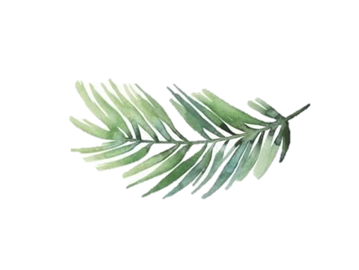
Dyke Neuk Takeaway Menu Served
Monday – Saturday 12-9PM

Starters
- Potato Skins Served with BBQ & Garlic Dipping Sauces £4.00 (V)
- Pan Fried Creamed Garlic Mushrooms Served on Homemade Toasted Sourdough Bread £4.50 (V) Coconut Milk (VG)
- Scottish Smoked Salmon & Sliced Avocado, Prawn Marie-Rose Salad £6.50 (GF)
Mains
- Whitby Whole Tail Breaded Scampi, homemade chips, garden peas or mushy peas £7.95
- Beer Battered Fillet of Fish, Homemade Chips, Mushy or Garden Peas £7.95
- Homemade Aberdeen Angus Beef Lasagne, Homemade Chips, Garlic Bread & Dressed Side Salad £7.95
- Chargrilled Boneless Flat Iron Half Chicken, with a Choice of Sauce: Lemon and Paprika, Blue Stilton, Peppercorn or Diane, Served with Creamy Dauphinoise Potatoes & Al Dentè Vegetables or Hand Cut Chips & Dressed Salad £8.95 (GF)
- Hanging Chicken Kebab, Chicken, Peppers, Mushrooms, Tomatoes with a Homemade Lemon & Tarragon or Garlic Butter Sauce, Served with Hand Cut Chips & House Salad £8.75
- Homemade 1/2lb Prime Steak Beef Burger, Served with French Fries, Homemade Coleslaw, Beer Battered Onion Rings, Relish, Lettuce & Tomato £7.95
Add an Extra Topping for £2.00 Choose from Cheese, Bacon or Pulled Pork

Kids Menu £3.95
- Cheeseburger & French Fries Beans or Peas
- Homemade Aberdeen Angus Beef Lasagne, French Fries & Garlic Bread
- Chicken Nuggets, French Fries Beans or Peas
- Teddy Bear Pizza & French Fries Beans or Peas
- Fish Fingers, French Fries Beans or Peas
Sides £2.50
Homemade Cooked Chips, Fries, Homemade Beer Battered Onion Rings, Mixed Dressed Salad, Sweet Potato Fries, Fresh Seasonal Vegetables, Dauphinoise Potatoes, Cheesy Garlic Bread Slices, Garlic Bread Slices
Vegetarian/Vegan dishes of the day
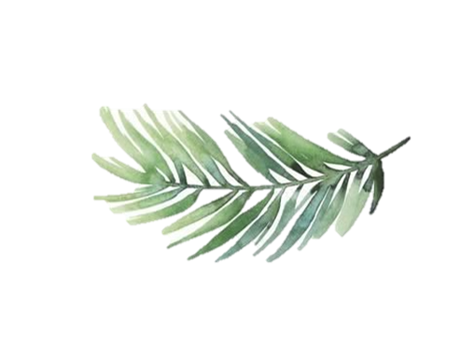
Please ask for details.
Desserts £4.00
Please ask for details.

