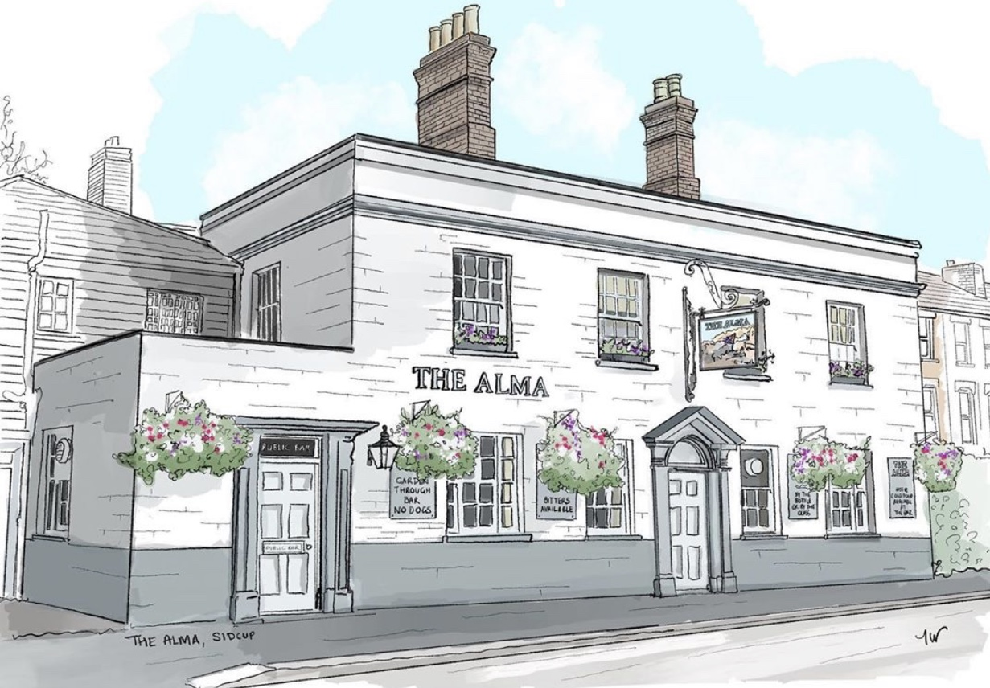
LUNCH TIME MENU
Served from 12pm-2:30pm Monday to Friday

All of our food is made fresh to order and at busy times your order can take around 20/25 minutes, if you are in a rush then unfortunately your food will not come any quicker. If you are a group of 5 or more then we kindly ask you to all order at the same time and not individually, if it helps you can always call/email your order to us.
Sandwiches/Baguettes
All sandwiches are served with crisps and a salad garnish with a salad dressing, choice of freshly baked sourdough baguette (allow up to 15 mins), thick white tiger bread or
thick sliced Hovis brown bread
Tuna mayo (can add sweetcorn) / Prawn mayo / Fish finger 4.90,
Beef & horseradish / Cheese & pickle (v) / Ham & mustard 4.50, Corned beef and Branston pickle 4.90 or
Hot dog baguette with fried onions, ketchup, mustard & a salad garnish 4.50
Toasties
All served with a salad garnish and a salad dressing, on thick white tiger bread or thick sliced Hovis brown bread
Cheese toastie 4.00 (v) with ham 4.20, with tomato or onion 4.10 (v),
cheese, ham, tomato and onion 4.30
Jacket Potatoes
with butter and grated mature cheddar (v)
with a choice of Heinz beans (v) 4.00, Tuna mayo (can add sweet corn) 4.50,
Prawn mayo 4.50, homemade spicy chilli con carne 4.50
Soup
Gazpacho (ve) served with croutons, peppers, cucumber and tomato 4.00
Soup of the day (v,ve) Served with bread and butter 3.00

If you have any allergies or intolerances, then please do let us know. As some of our dishes may contain allergens, we cannot guarantee that our food is allergen free. (v) vegetarian friendly, (ve) vegan friendly.
LUNCH TIME MENU
Served from 12pm-2:30pm Monday to Friday

All of our food is made fresh to order and at busy times your order can take around 20/25 minutes, if you are in a rush then unfortunately your food will not come any quicker. If you are a group of 5 or more then we kindly ask you to all order at the same time and not individually, if it helps you can always call/email your order to us.

9” stuffed crust pizzas, 7.00 each
(Please allow up to 20 minutes as these are cooked fresh to order)
Cheddar & mozzarella cheese feast with a cheese stuffed crust (v)
Ultimate garlic & cheese with a cheese stuffed crust (v)
BBQ meat feast / BBQ chicken & bacon / beef doner kebab pizza / double pepperoni pizza, all come with a cheese stuffed crust
Cheese and tomato pizza with a hot dog stuffed crust
Add jalapenos (v) 50p
Mains
The Famous Alma Ploughman’s 6.50
Pie on its own (v,ve) 3.50 with chips and gravy (v,ve) 6.50
Scampi and chips served with a lemon wedge and a salad garnish 6.50
Beer battered cod fillet and chips served with a lemon wedge and a salad garnish 7.50 (please allow up to 15 minutes)
Cathedral city cheddar and ham hock quiche served with salad £5.00
Baked beef lasagne served with chips and a salad garnish 6.50
(please allow up to 17 minutes)
Want to spice up your lasagne? Ask when placing your order
Sides
Chips (v,ve) 3.50, Cheesy chips (v) 4.00, Cheesy jalapeno chips(v) 4.50
If you have any allergies or intolerances, then please do let us know. As some of our dishes may contain allergens, we cannot guarantee that our food is allergen free. (v) vegetarian friendly, (ve) vegan friendly.

