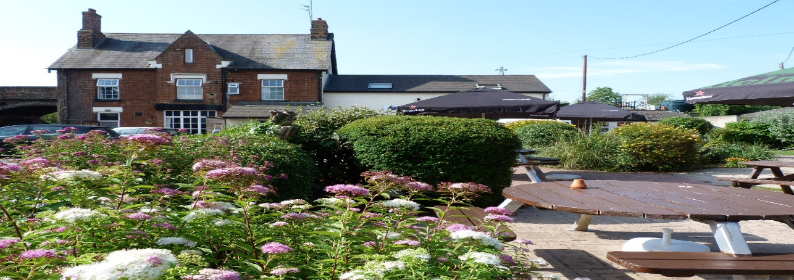

The Railway Inn
Station Road, Culham, OX14 3BT
Phone 01235 528046
Sunday Roasts Takeaway 12 – 2.00pm £9.00 Phone to place an order Saturday

Takeaway Lunchtime and Evening Menu
Cottage Pie, Cheese Topping with Vegetables £9.95
Cod, Chips and Peas £9.95
Lasagne, Chips and Garlic Bread 9.95
Chicken Skewers with Salad £5.25
Beef Burger with Cheese and Onion £5.00
Wednesday Roast £9.00
Moo and Blue Stilton Pie, Mash, Peas and Gravy £8.50

Call us for more information

