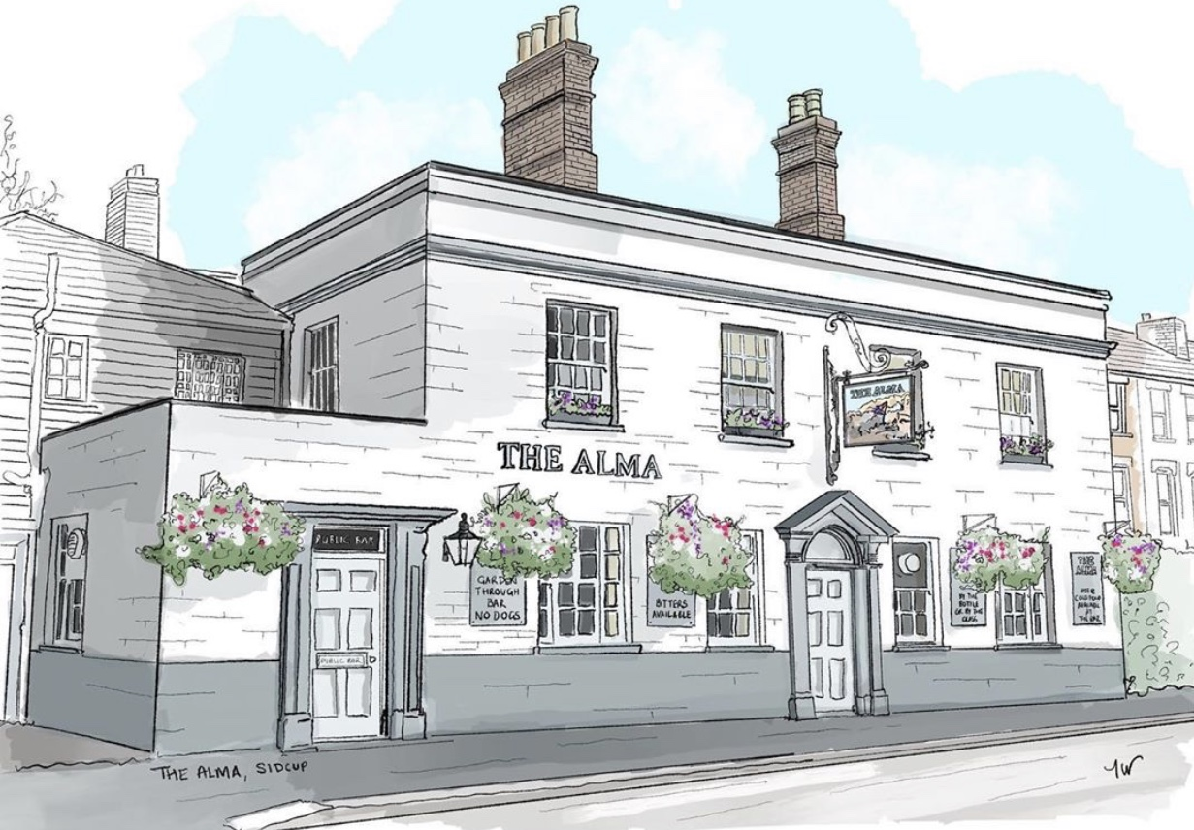
LUNCH TIME MENU
Served from 12pm-2pm Monday to Friday

All of our food is made fresh to order and at busy times your order can take around 20 minutes, if you are in a rush then unfortunately your food will not come any quicker. If you are a group of 5 or more then we kindly ask you to all order at the same time and not individually, if it helps you can always call/email your order to us.

Pies
5.00 with mash
Steak & ale, chicken & mushroom, vegetable brie wellington (v) stilton & spinach wellington (v) or keralan vegan curry pasty (ve)
Toasties
on white or brown 4.00
Cheese toastie (v) with a choice of ham, tomato (v) or onion (v)
Jacket Potatoes
with butter and grated mature cheddar (v)
with a choice of Heinz beans (v) or tuna mayo 4.00
Soup
Soup of the day (V) Served with bread and butter 2.50

If you have any allergies or intolerances, then please do let us know. As some of our dishes may contain allergens, we cannot guarantee that our food is allergen free. (v) vegetarian friendly, (ve) vegan friendly.

Keep up to date with what is happening at The Alma:
Facebook: The Alma Pub Sidcup, Instagram: TheAlmaPubSidcup, Twitter: TheAlmaSidcup W: www.thealmapub.co.uk,
E: info@thealmapub.co.uk, 10 Alma Road, Sidcup, Kent, DA14 4EA
LUNCH TIME MENU
Served from 12pm-2pm Monday to Friday

All of our food is made fresh to order and at busy times your order can take around 20 minutes, if you are in a rush then unfortunately your food will not come any quicker. If you are a group of 5 or more then we kindly ask you to all order at the same time and not individually, if it helps you can always call/email your order to us.

Tier 2 Pizza offer, 5.00 each
Pizzas & Flatbreads available all day every day
Four cheese & balsamic red onion (v) 5.00
Spicy chicken & chargrilled red pepper 5.00
Buffalo mozzarella & sun soaked tomatoes (v) 5.00
Spicy salami & red chili 5.00
Red Leicester, mature cheddar & balsamic red
onion flatbread (v) 2.00
Basil Pesto & Tomato flatbread (v) 2.00
Garlic & parsley ciabatta slice (ve) 2.00
Caramelised garlic & extra virgin olive oil 9” flatbread (ve) 2.50

Ask for today’s specials

If you have any allergies or intolerances, then please do let us know. As some of our dishes may contain allergens, we cannot guarantee that our food is allergen free. (v) vegetarian friendly, (ve) vegan friendly.

Keep up to date with what is happening at The Alma:
Facebook: The Alma Pub Sidcup, Instagram: TheAlmaPubSidcup, Twitter: TheAlmaSidcup W: www.thealmapub.co.uk,
E: info@thealmapub.co.uk, 10 Alma Road, Sidcup, Kent, DA14 4EA

