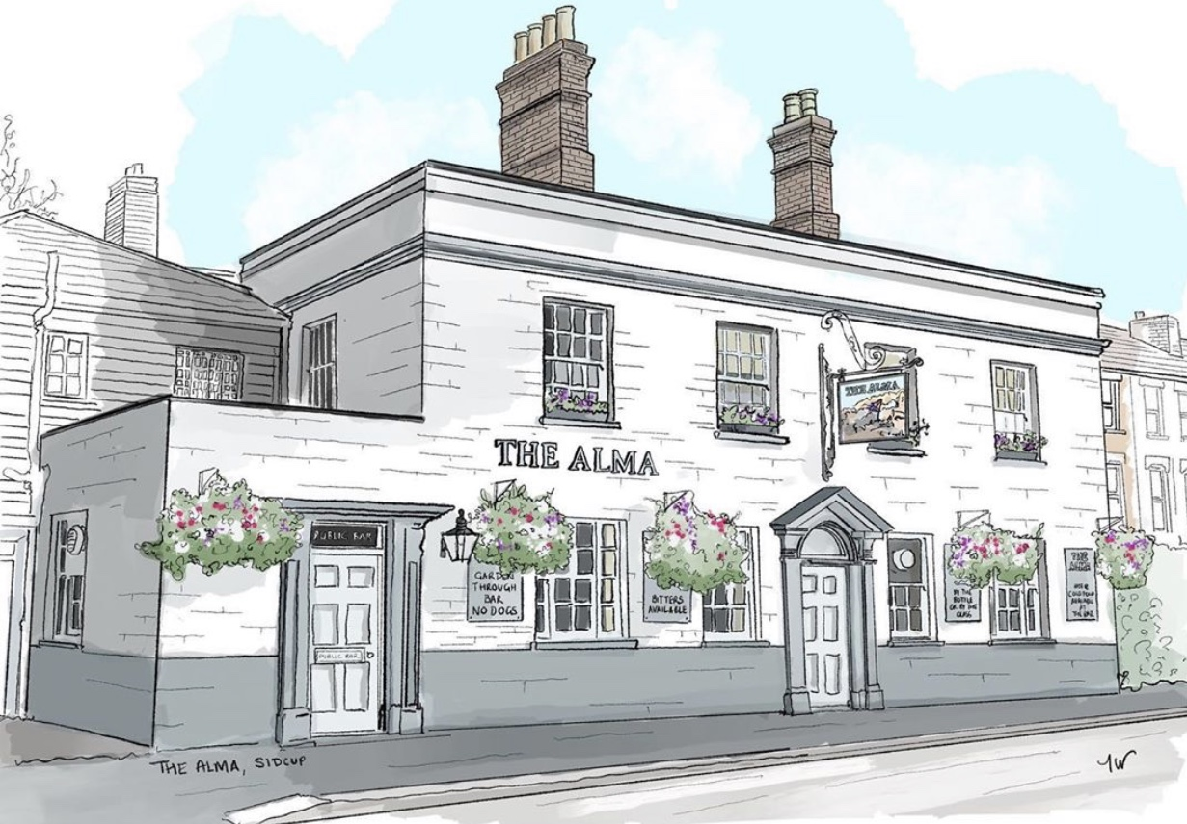
BRUNCH/LUNCH MENU
Served from 11am-2:30pm Tuesday to Friday

All of our food is made fresh to order and at busy times your order can take around 20/25 minutes, unless otherwise stated on the menu, if you are in a rush then unfortunately your food will not come any quicker. If you are a group of 5 or more then we kindly ask you to all order at the same time and not individually, if it helps you can always call/email your order to us.

Breakfast/Brunch
All breakfast/brunch sandwiches are served on either thick white bread or thick sliced Hovis brown bread and come with a choice of Heinz tomato ketchup or HP brown sauce
Bacon or sausage or fried egg sandwich 3.50
Scrambled egg (2 eggs) or 2 fried eggs or Heinz beans or tinned tomatoes on 2 toast 4.30
Alma breakfast, 2 fried eggs, 2 sausages, 2 bacon, tinned tomatoes, Heinz beans and 2 buttered toast 7.50
Breakfast extras 1.00 each, fried egg, 2 x sausage, 2 x bacon, Heinz beans, tinned tomatoes
Mains
The Alma omelette, cheese, ham, cherry tomatoes & peppers (v) 6.00
Plain omelette, just egg (v) 4.50, Cheese or Ham omelette (v) 5.00
All omelettes come with a salad garnish and salad dressing
Pie on its own (v,ve) 3.50 with chips and gravy (v,ve) 6.50 (please allow up to 40 minutes as these, like everything else, are cooked fresh to order)
Scampi and chips served with a lemon wedge and a salad garnish 7.00
Beer battered cod fillet and chips served with a lemon wedge and a salad garnish 7.00 (please allow up to 20 minutes)
Baked beef or mushroom lasagne served with chips and a salad garnish 7.00
(please allow up to 15 minutes) Want to spice up your lasagne? Just ask
If you have any allergies or intolerances, then please do let us know. As some of our dishes may contain allergens, we cannot guarantee that our food is allergen free. (v) vegetarian friendly, (ve) vegan friendly.
Sandwiches/Baguettes
All sandwiches are served with crisps and a salad garnish with salad dressing, choice of freshly baked sourdough baguette (allow up to 15 mins), thick white tiger bread or
thick sliced Hovis brown bread
Tuna mayo (can add sweetcorn) / Prawn mayo / Fish finger 4.90,
Cheese & pickle (v) / Ham & mustard / Hot dog baguette with fried onions 4.50,
Corned beef and Branston pickle 4.90
Toasties
All served with a salad garnish and salad dressing, on thick white tiger bread or thick sliced Hovis brown bread
Cheese toastie 4.00 (v) with ham or with tomato or onion 4.20 (v),
cheese, ham, tomato and onion 4.50
Jacket Potatoes
with butter and grated mature cheddar (v)
with a choice of Heinz beans (v) 4.50, Tuna mayo (can add sweet corn),
Prawn mayo or homemade spicy chilli con carne 5.00
Soup
Soup of the day (v,ve) Served with bread and butter 3.50
9” stuffed crust pizzas, 7.50 each
(Please allow up to 22 minutes as these are cooked fresh to order)
Ask what pizzas are available
Sides
Chips (v,ve) 3.50, Cheesy chips (v) 4.00, Cheesy jalapeno chips(v) 4.50

If you have any allergies or intolerances, then please do let us know. As some of our dishes may contain allergens, we cannot guarantee that our food is allergen free. (v) vegetarian friendly, (ve) vegan friendly.

