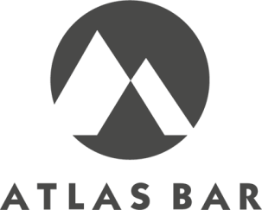
SMALL PLATES £
Tomato & courgette soup, crusty bread & butter(v) 4

Pork & apple pie, cider jelly with piccalilli 3

Chicken liver pate, pickles, bread & butter 4

Mushrooms & spinach on toast, poached egg & parsley sauce(v) 4

LARGE PLATES
Pork & beef meatball lasagna, mixed salad 7

Red pepper & Goats cheese pie, pickled tomato's & mixed salad(v) 7

Beef burger, brioche bun, caramelised onions, tomato 9 gem lettuce, fries

Fish & Chips, lightly battered Cod, mushy peas 8 tartare sauce, chunky chips

SHARING PLATES
Ploughman’s platter, pork pie, pate, cheese & pickles 12 bread, crackers, butter

Nachos, melted cheddar cheese, jalapeños, salsa, sour cream(v) 8

SANDWICHES
BLT, smoked back bacon, gem lettuce, tomato & mayonnaise, fries 6

Ham, Lancashire cheese, mustard, mixed salad, fries 5

Tuna, sweet corn, red onion toasted sandwich, mixed salad, fries 5

Brie, roast red pepper & spinach, mixed salad, fries (v) 5

SOUP & SANDWICH £7
Tomato & courgette soup with one of the following
Ham, Lancashire cheese & mustard
Smoked mackerel pate, piccalilli & gem lettuce
Brie, roast red pepper & spinach (v)

SIDE ORDERS
French fries 2
Chunky chips 3
Mixed salad, tomato, cucumber, radish & gem lettuce 2

